NAMA : ______________________________________________ TARIKH : ________________________
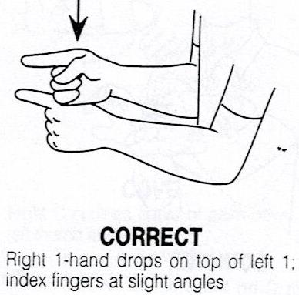

P A D A N K A N WARNA / COLOUR Y A N G TEPAT / CORRECT.
SPELLING | SIGN LANGUAGE | COLOUR
RED
PINK
BLUE
GREY
YELLOW

