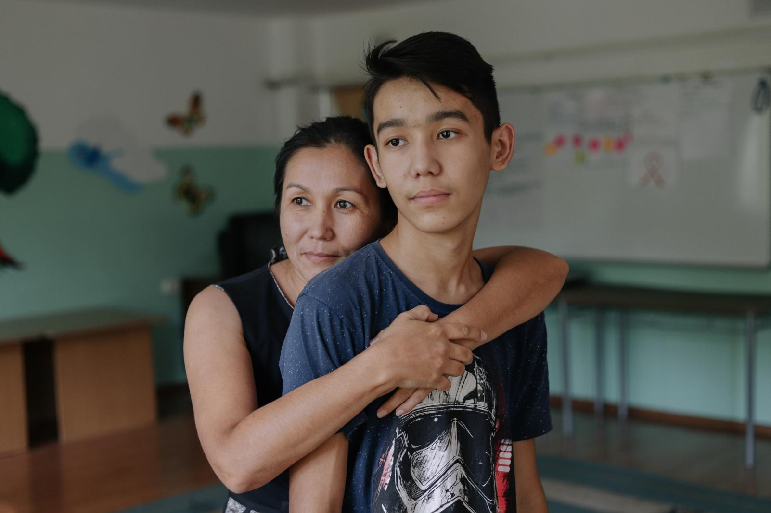

6 ways parents can support their kids through the coronavirus disease (COVID-19) outbreak
www.unicef.org
5 mins read

A psychologist's advice on how to help your children deal with the many emotions they may be experiencing now.
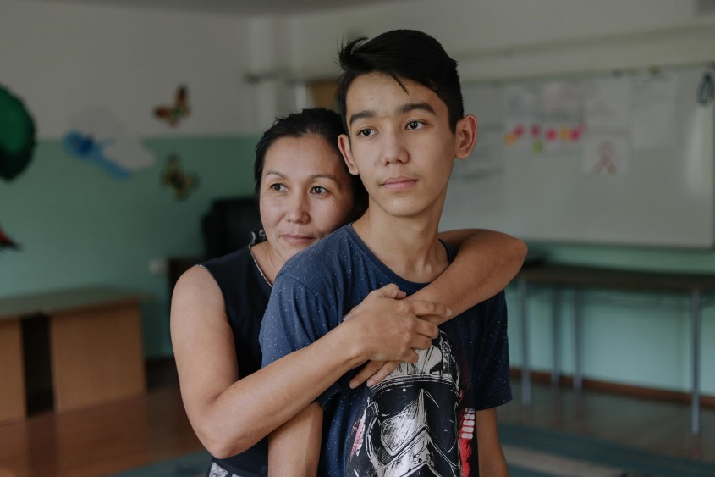
UNICEF/UNI210287/Kazakhstan
< Back to UNICEF COVID-19 portal
The coronavirus disease (COVID-19) brings with it feelings like anxiety, stress and uncertainty — and they are felt especially strongly by children of all ages. Though all children deal with such emotions in different ways, if your child has been faced with school closures, cancelled events or separation from friends, they are going to need to feel loved and supported now more than ever.
We spoke with expert adolescent psychologist, best-selling author, monthly New York Times columnist and mother of two Dr. Lisa Damour about how you can help create a sense of normalcy at home while navigating “the new (temporary) normal.”

1. Be calm and proactive
“Parents should have a calm, proactive conversation with their children about the coronavirus disease (COVID-19), and the important role children can play in keeping themselves healthy. Let them know that it is possible that [you or your children] might start to feel symptoms at some point, which are often very similar to the common cold or flu, and that they do not need to feel unduly frightened of this possibility,” recommends Dr. Damour. “Parents should encourage their kids to let them know if they're not feeling well, or if they are feeling worried about the virus so that the parents can be of help.”
“Adults can empathize with the fact that children are feeling understandably nervous and worried about COVID-19. Reassure your children that illness due to COVID-19 infection is generally mild, especially for children and young adults,” she says. It’s also important to remember, that many of the symptoms of COVID-19 can be treated. “From there, we can remind them that there are many effective things we can do to keep ourselves and others safe and to feel in better control of our circumstances: frequently wash our hands, don't touch our faces and engage in social distancing.”
"Another thing we can do is actually help them look outward. So to say to them, ‘Listen, I know you’re feeling really anxious about catching coronavirus, but part of why we’re asking you to do all these things — to wash your hands, to stay home — is that that’s also how we take care of members of our community. We think about the people around us, too.’”
>> How to talk to your kids about COVID-19
>> Read our tips on handwashing

2. Stick to a routine
“Children need structure. Full stop. And what we’re all having to do, very quickly, is invent entirely new structures to get every one of us through our days,” says Dr. Damour. “I would strongly recommend that parents make sure that there’s a schedule for the day — that can include playtime where a kid can get on their phone and connect with their friends, but it also should have technology-free time and time set aside to help around the house. We need to think about what we value and we need to build a structure that reflects that. It will be a great relief to our kids to have a sense of a predictable day and a sense of when they’re supposed to be working and when they get to play.”
She suggests getting your children involved too. “For children 10 and 11 or older, I would ask the child to design it. Give them a sense of the kinds of things that should be included in their day, and then work with what they create.” When it comes to younger children, “depending on who is supervising them (I realize that not every parent is going to be home to do this) structure their day so that all of the things that need to get done before anything else happen: all of their schoolwork and all of their chores. For some families, doing that at the start of the day will work best for kids. Other families may find it may work okay to start the day a little bit later after sleeping in and enjoying breakfast together as a family.” For parents who are not able to supervise their children during the day, explore with your caretaker ways to create a structure that works best.

“Support, expect and normalize that they are very sad and very frustrated about the losses they are mourning.”

3. Let your child feel their emotions
With school closures come cancelled school plays, concerts, sports matches and activities that children are deeply disappointed about missing out on because of the coronavirus disease (COVID-19). Dr. Damour’s number one piece of advice is to let them be sad. “In the scope of an adolescent’s life these are major losses. This is bigger for them than it is for us because we’re measuring it against our lifetime and experience. Support, expect and normalize that they are very sad and very frustrated about the losses they are mourning.” When in doubt, empathy and support are the way to go.

4. Check in with them about what they’re hearing
There is a lot of misinformation circulating about the coronavirus disease (COVID-19). “Find out what your child is hearing or what they think is true. It’s not enough to just tell your child accurate facts, because if they have picked up something that is inaccurate, if you don’t find out what they are thinking and directly address the misunderstanding, they may combine the new information you give them with the old information they have. Find out what your child already knows and start from there in terms of getting them on the right track.”
If they have questions you can’t answer, instead of guessing, use it as an opportunity to explore the answers together. Use websites of trusted organizations like UNICEF and the World Health Organization for sources of information.
Many children are facing bullying and abuse at school or online around the coronavirus disease (COVID-19). It’s important your children know that you’re always there for them should they experience bullying. “Activating bystanders is the best way to address any kind of bullying,” says Dr. Damour. “Kids who are targeted should not be expected to confront bullies; rather we should encourage them to turn to friends or adults for help and support.”
>> Get the facts: Read our coronavirus disease (COVID-19) explainer for parents
>> How to talk to your child about bullying

5. Create welcome distractions
When it comes to processing difficult emotions, “take your cues from your child, and really think a lot about balancing talking about feelings with finding distractions, and allow distractions when kids need relief from feeling very upset.” Have a family game night every few days or cook meals together. Dr. Damour is using dinner time to connect with her daughters. “We’ve decided that we are going to have a dinner team every night. We mix it up in pairs, so we rotate who is in charge of making dinner for the family.”
With teens and their screens, allow for some leeway, but not a free-for-all. Dr. Damour advises to be up front with your teenager and say that you understand they have more time on their hands, but that it’s not going to be a good idea to have unfettered access to screens or social media. “Ask your teen, ‘how should we handle this? Come up with a structure and show me the structure that you’re thinking about, and then I’ll let you know what I think.’”

6. Monitor your own behaviour
“Parents of course are anxious too and our kids will take emotional cues from us,” explains Dr. Damour. “I would ask parents to do what they can to manage their anxiety in their own time and to not overshare their fears with their children. That may mean containing emotions, which may be hard at times, especially if they’re feeling those emotions pretty intensely.”
Children rely on their parents to provide a sense of safety and security. “[It’s important that] we remember that they are the passengers in this and we are driving the car. And so even if we’re feeling anxious, we can’t let that get in the way of them feeling like safe passengers.”

< Back to UNICEF COVID-19 portal

Interview and article by Mandy Rich, Digital Content Writer, UNICEF

