Further Practice 12.1

Basic

- Copy the line segment AB on a grid paper.
(a) Rotate AB 90° anticlockwise about the origin O. Draw and label the image A₁B₁.
(b) Rotate AB 180° about the point P(1, 1). Draw and label the image A₂B₂.

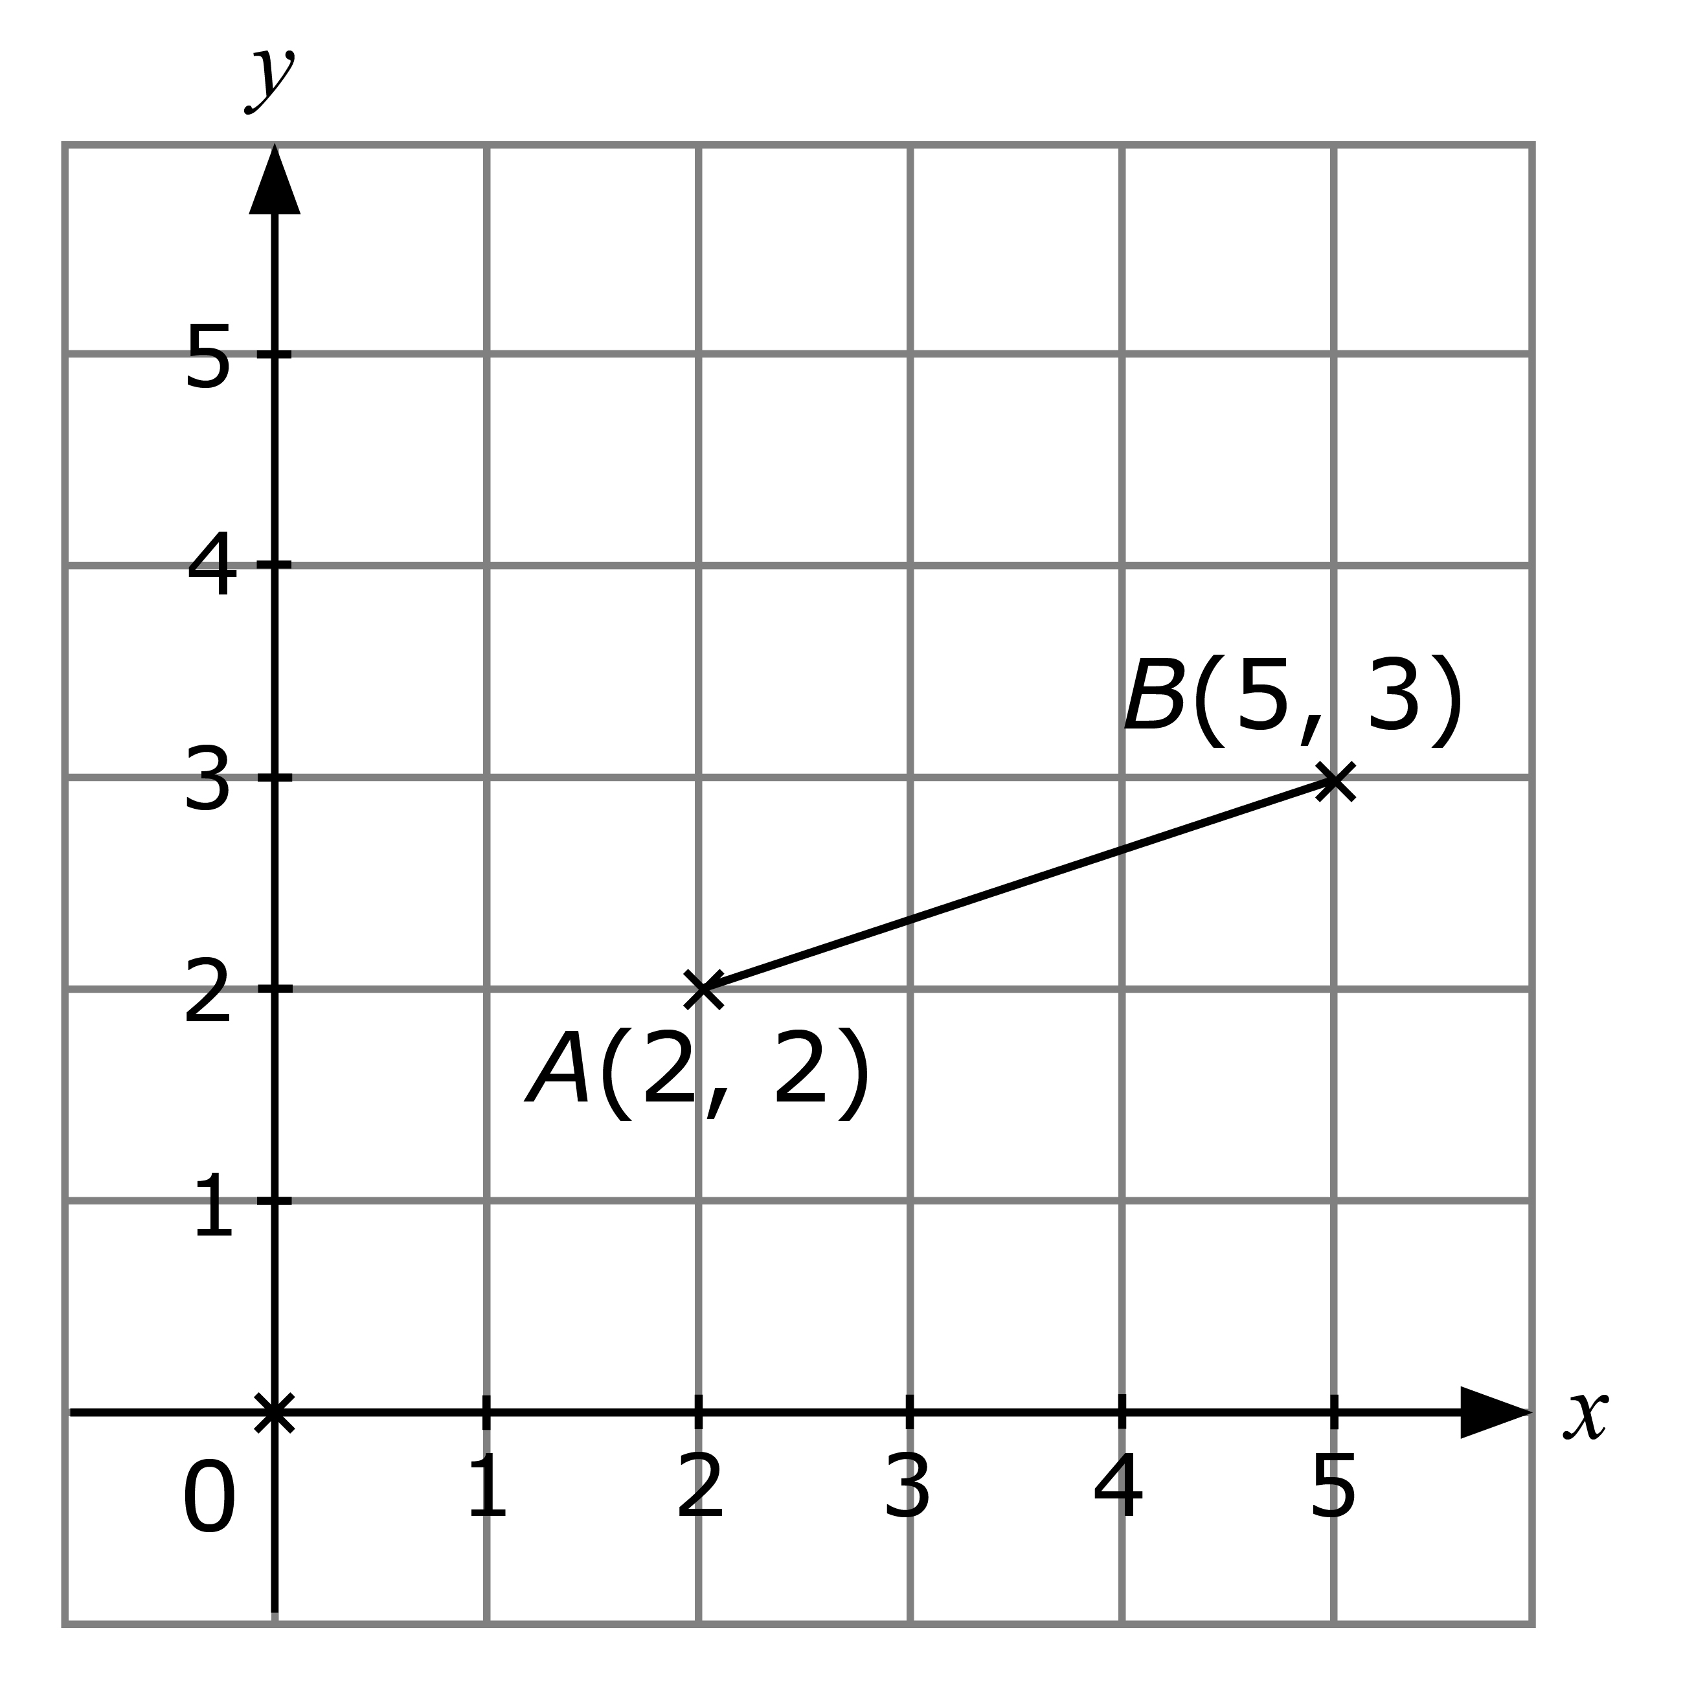

- Copy the quadrilateral CDEF on a grid paper. Rotate the quadrilateral 90º clockwise about the origin O. Draw and label the image C₁D₁E₁F₁.
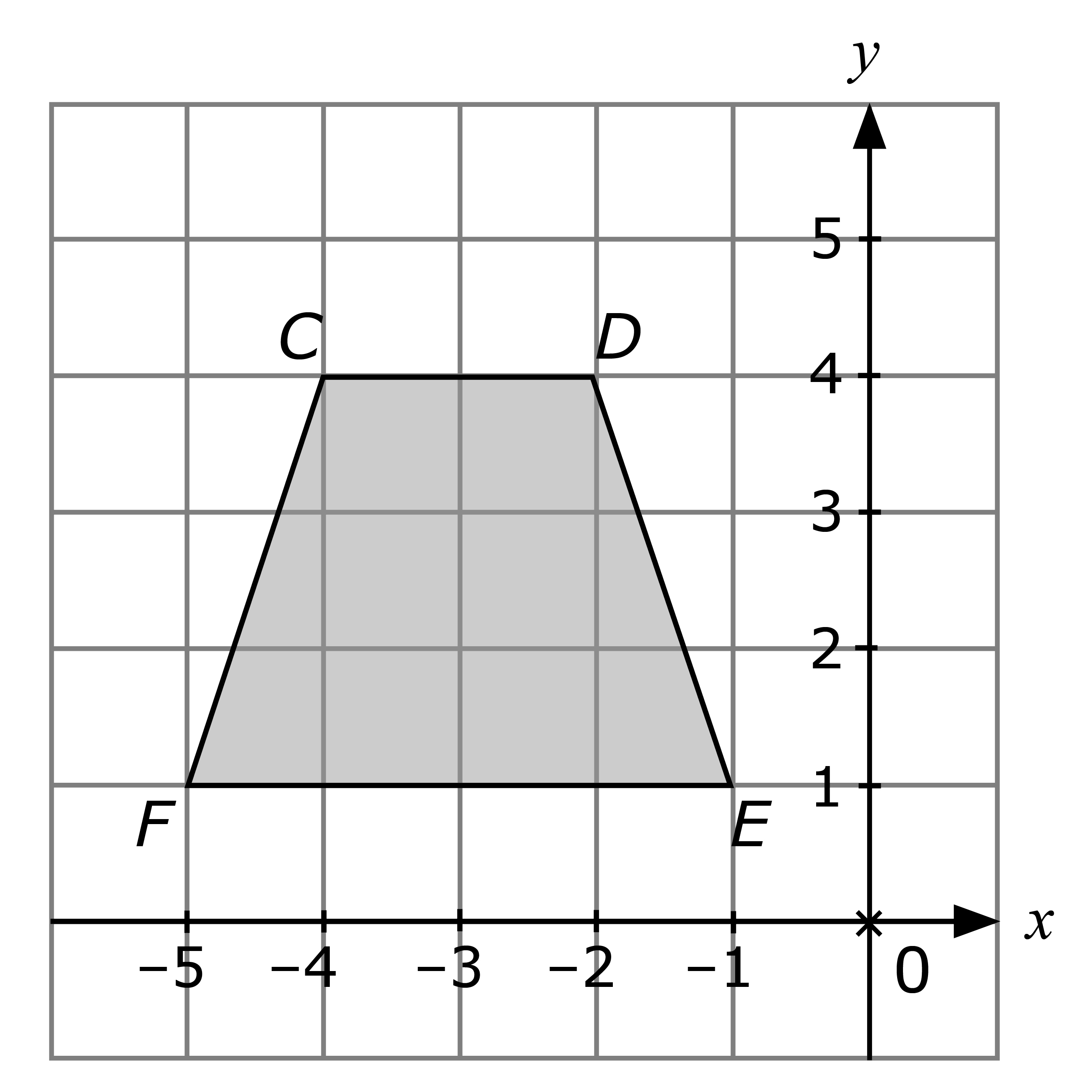

Intermediate

- The diagram shows a line segment ST and a point A. Copy the diagram on a piece of plain paper.
(a) Rotate ST 90º clockwise about the point A. Draw and label the image S₁T₁.
(b) Rotate ST 180º about the point A and label the image S₂T₂.

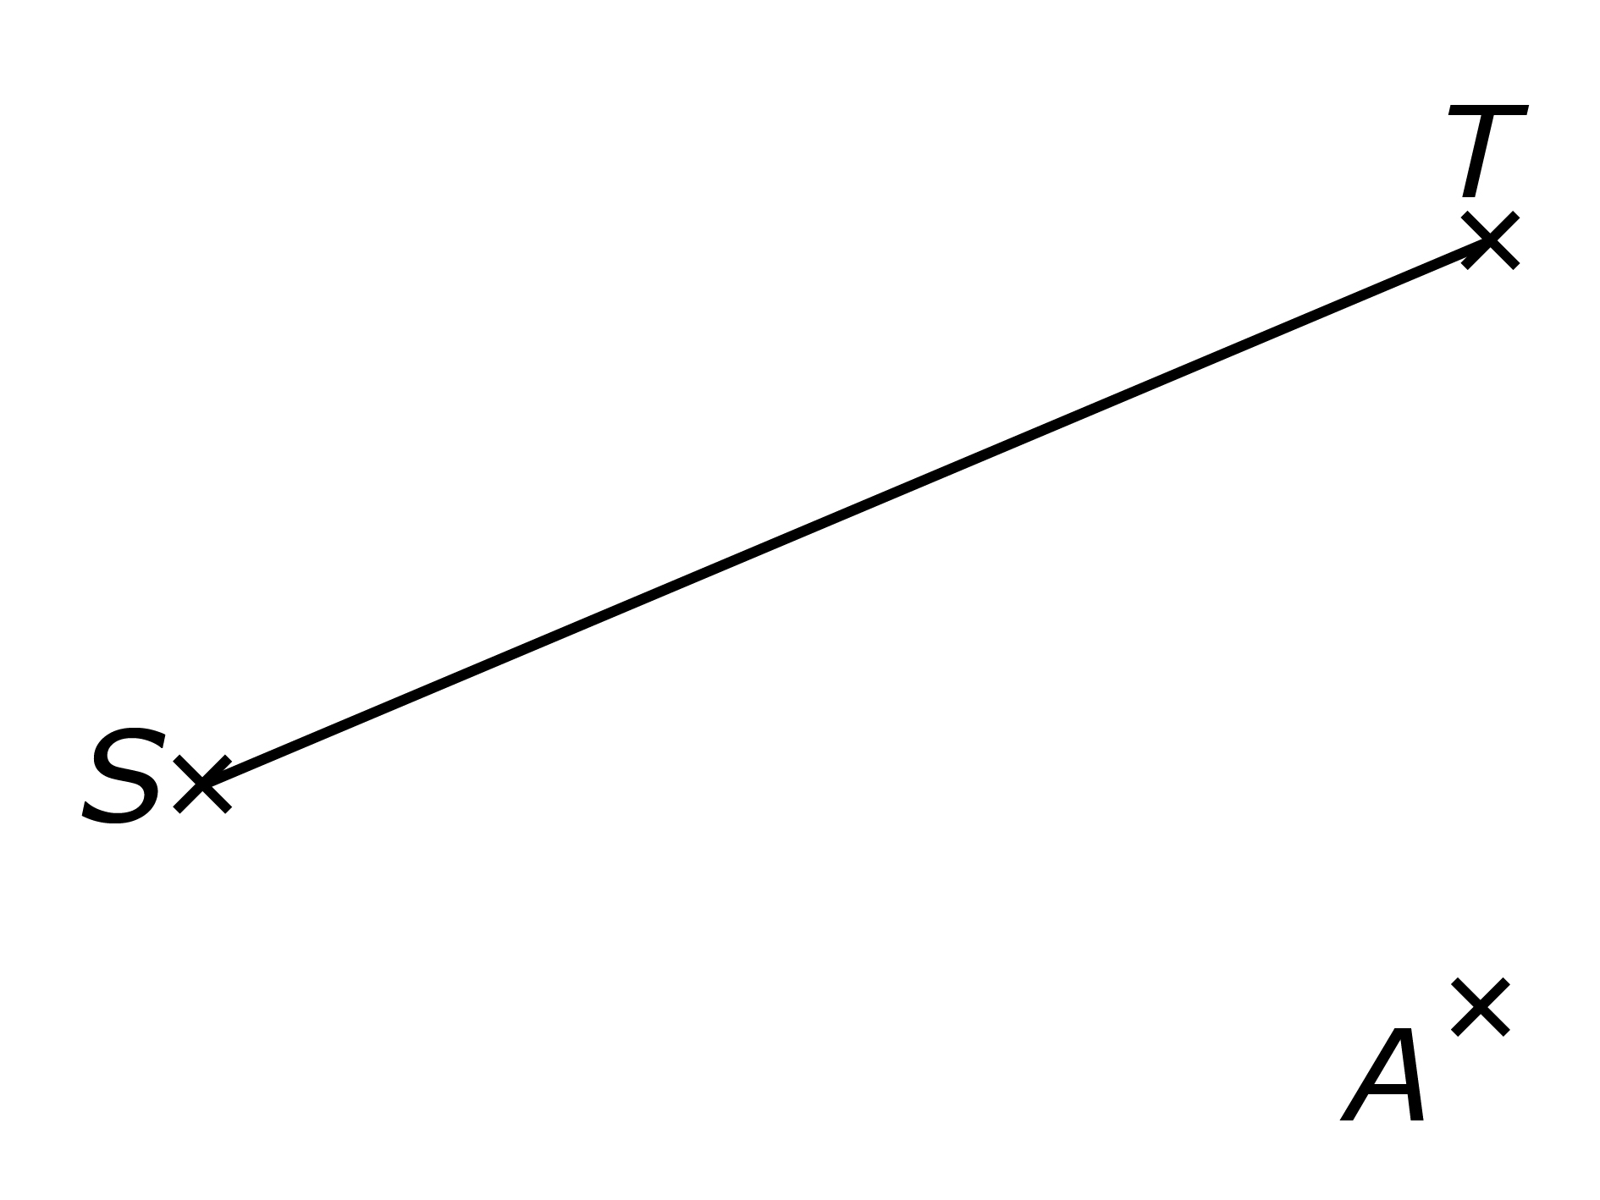

- The diagram shows a quadrilateral KLMN and a point C. The quadrilateral is rotated 90º anticlockwise about the point C. Copy the diagram on a piece of plain paper and draw the image K₁L₁M₁N₁.

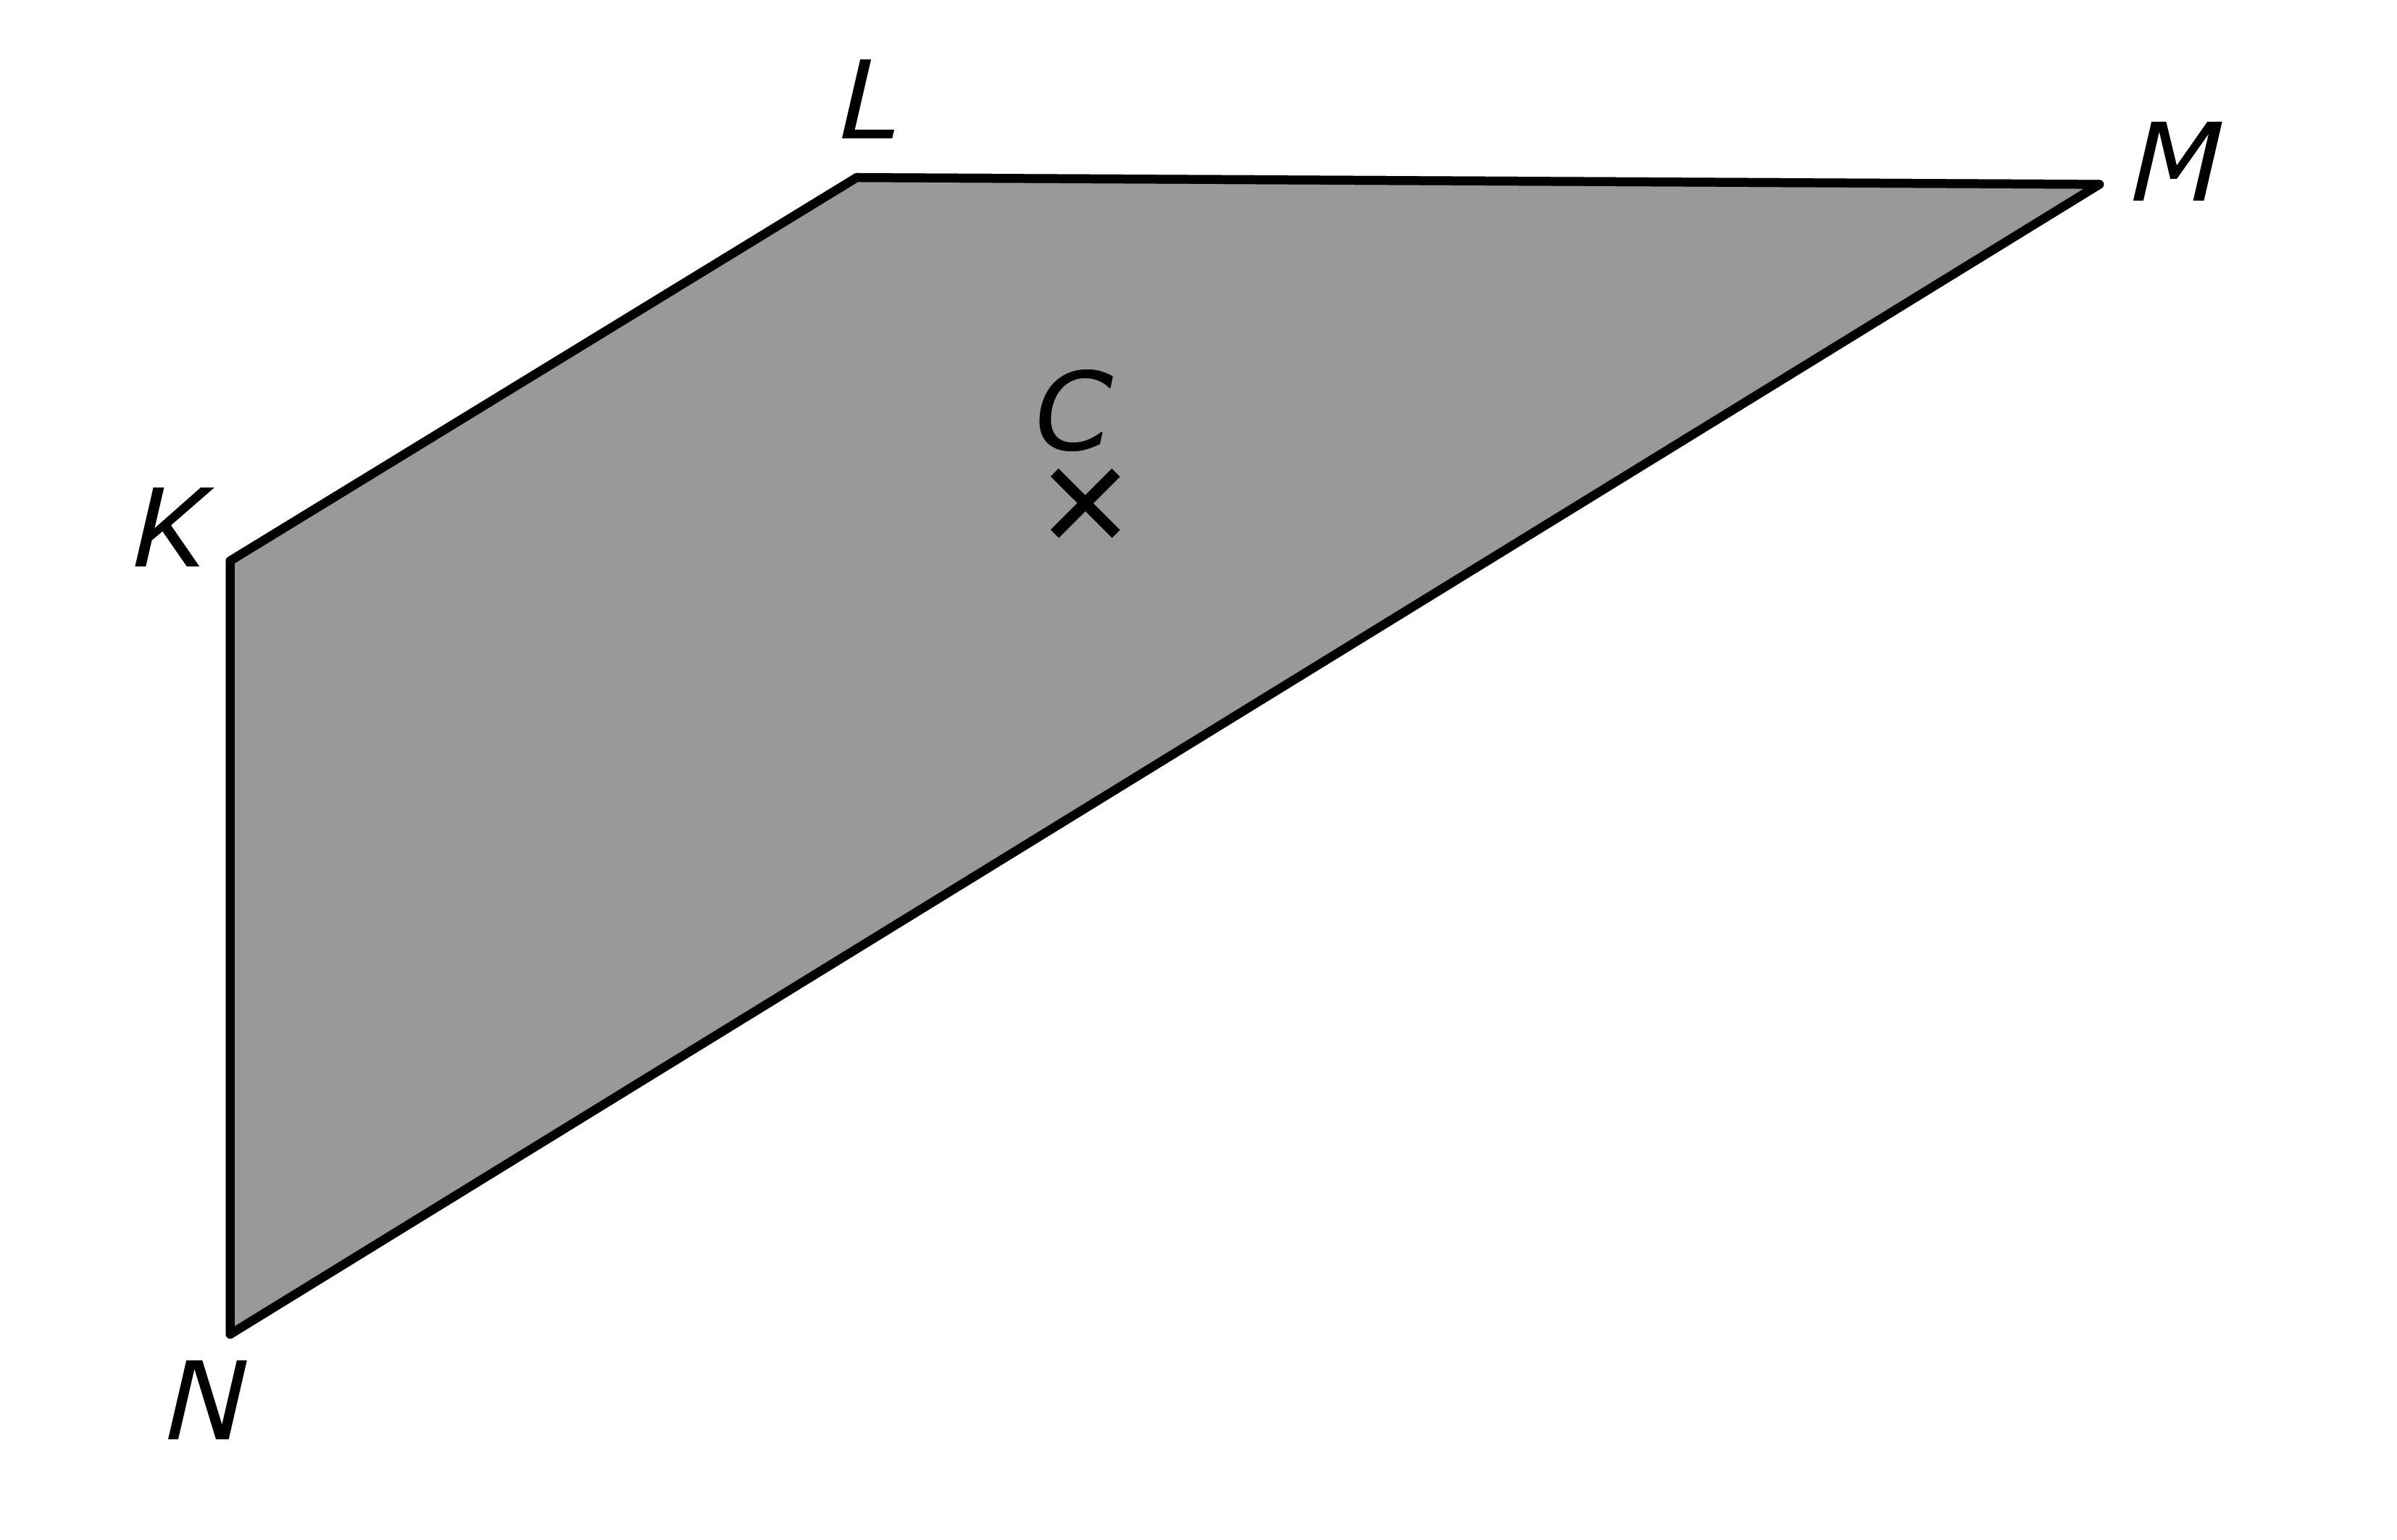

Challenging

- The diagram below shows a segment of the line y = 2x + 1. Copy the line on a grid paper.
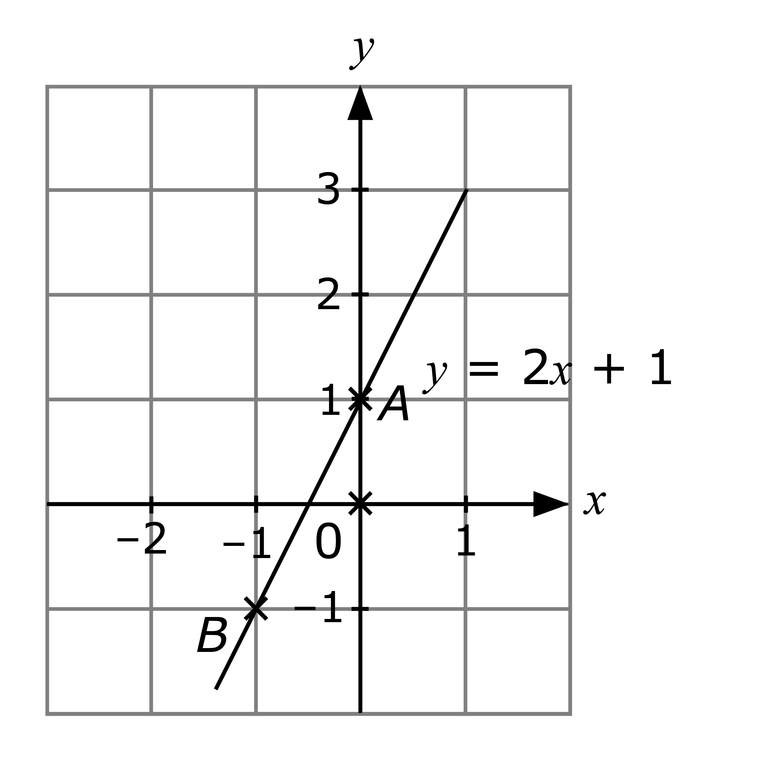
(a) On separate grids, draw the image of the line given that
(i) the line is rotated 90º anticlockwise about the origin O,
(ii) the line is rotated 90º clockwise about the point A,
(iii) the line is rotated 90º clockwise about the point B.
(b) Find the equation of each line in parts (i) to (iii).

Further Practice 12.2

Basic

- Copy the quadrilateral KLMN on a grid paper. Enlarge the quadrilateral with scale factor 3 and centre O(0, 0). Draw and label the image K₁L₁M₁N₁.

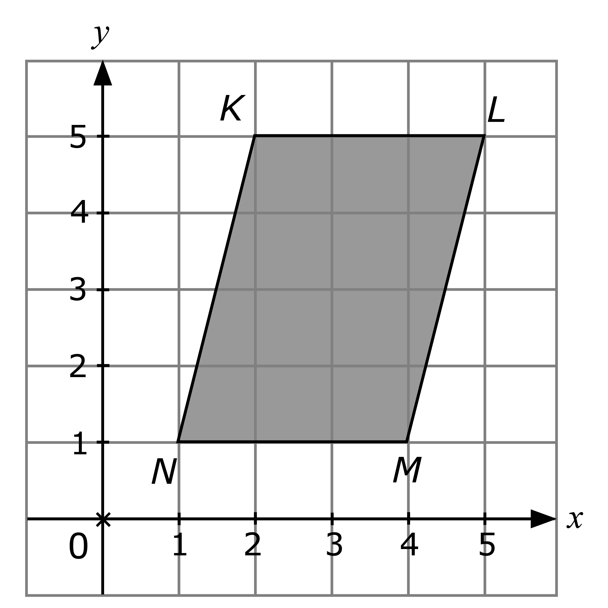

- Copy the line segment AB on a grid paper. Enlarge the line segment with scale factor 0.5 and centre C(1, 0). Draw and label the image A₁B₁.

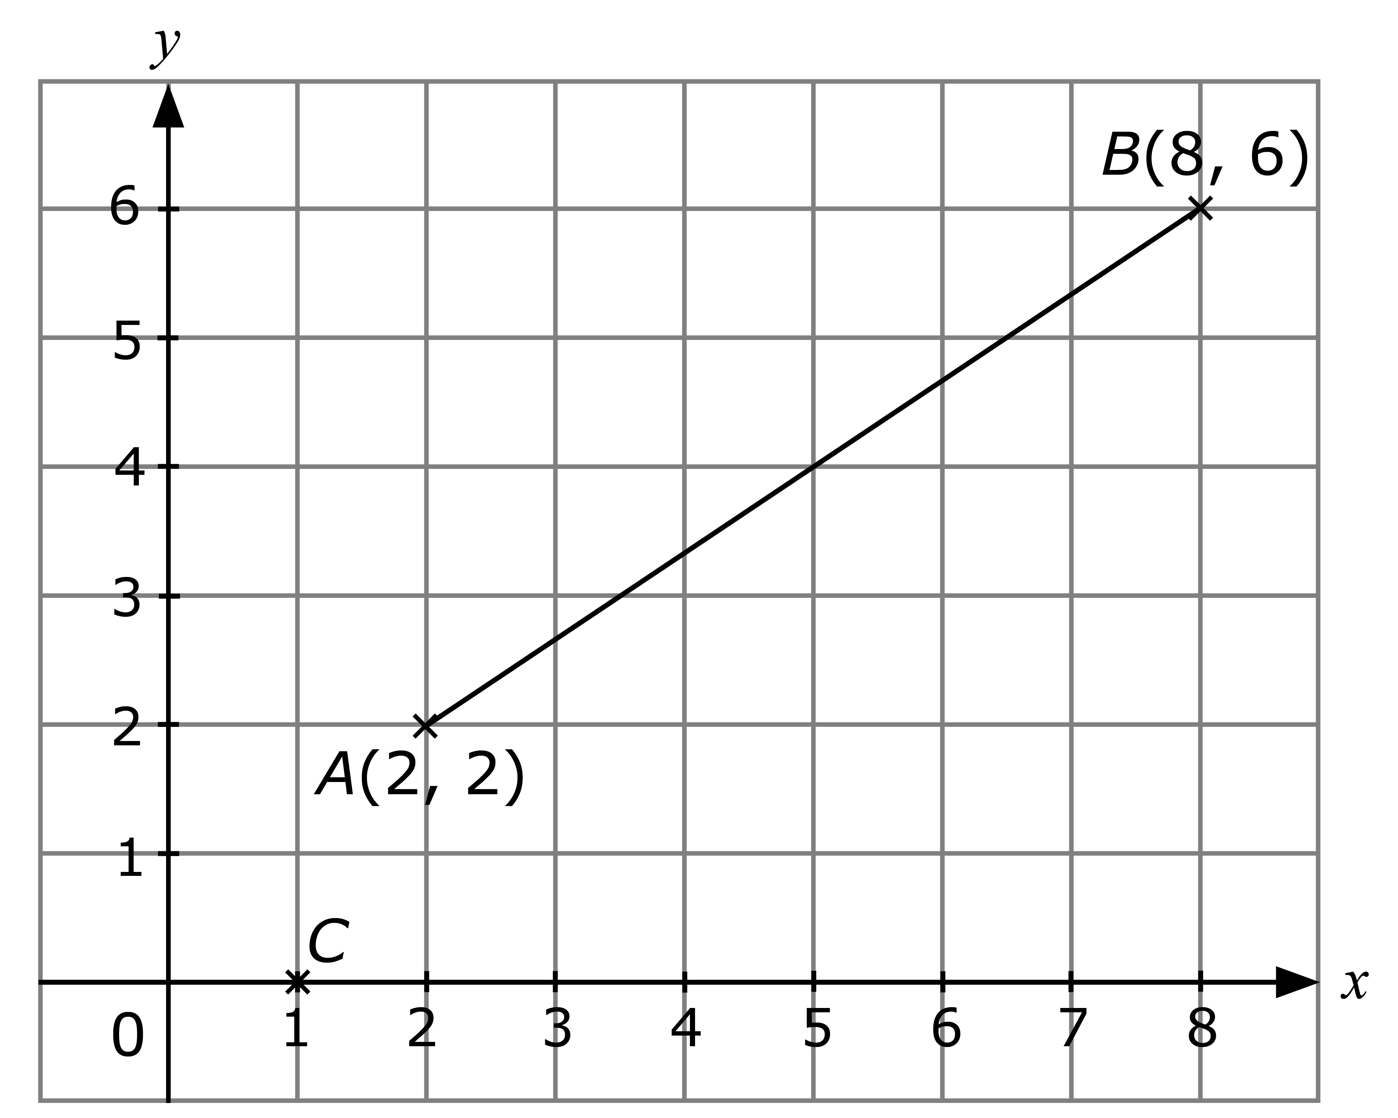

Intermediate

- In the diagram, rectangle S can be mapped onto rectangle T by an enlargement. Find
(a) the coordinates of the centre of enlargement,
(b) the scale factor.
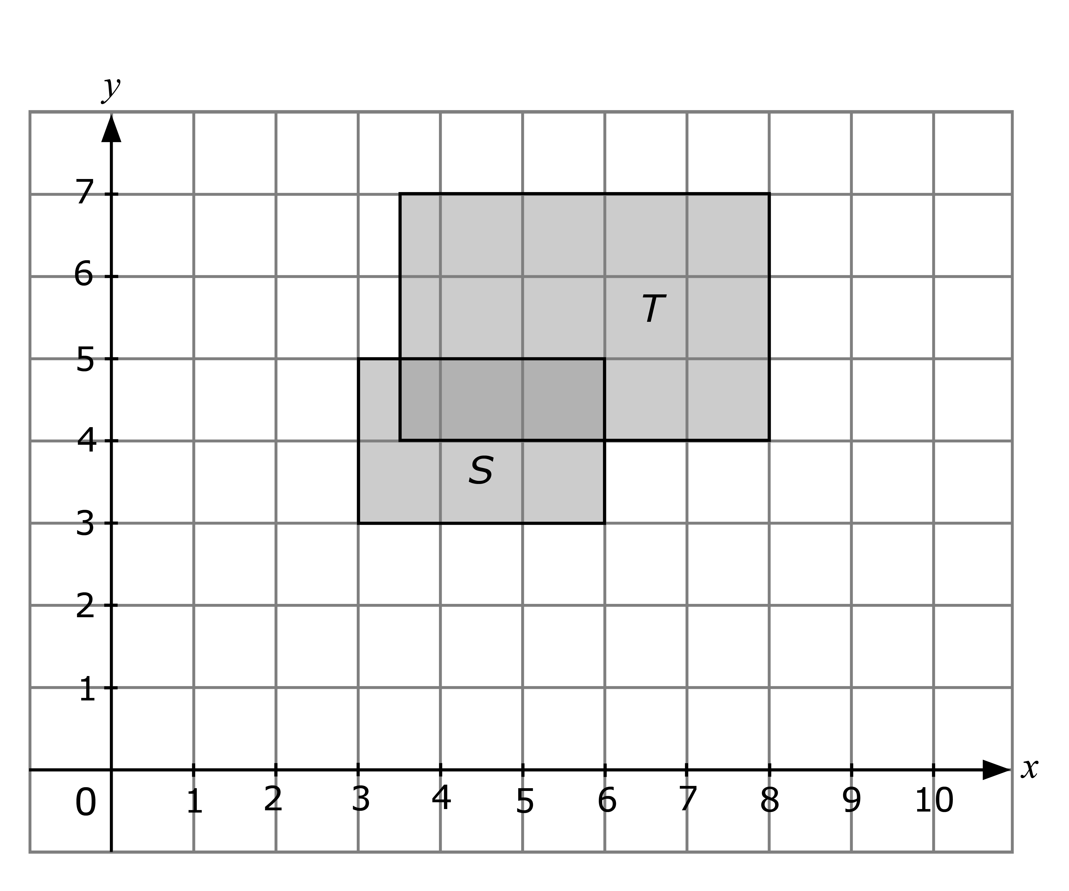

- The triangles DEF and KLM are such that DE, EF and DF are parallel to KL, LM and KM respectively. LM = 4.8 cm, KM = 4.2 cm and EF = 1.92 cm.

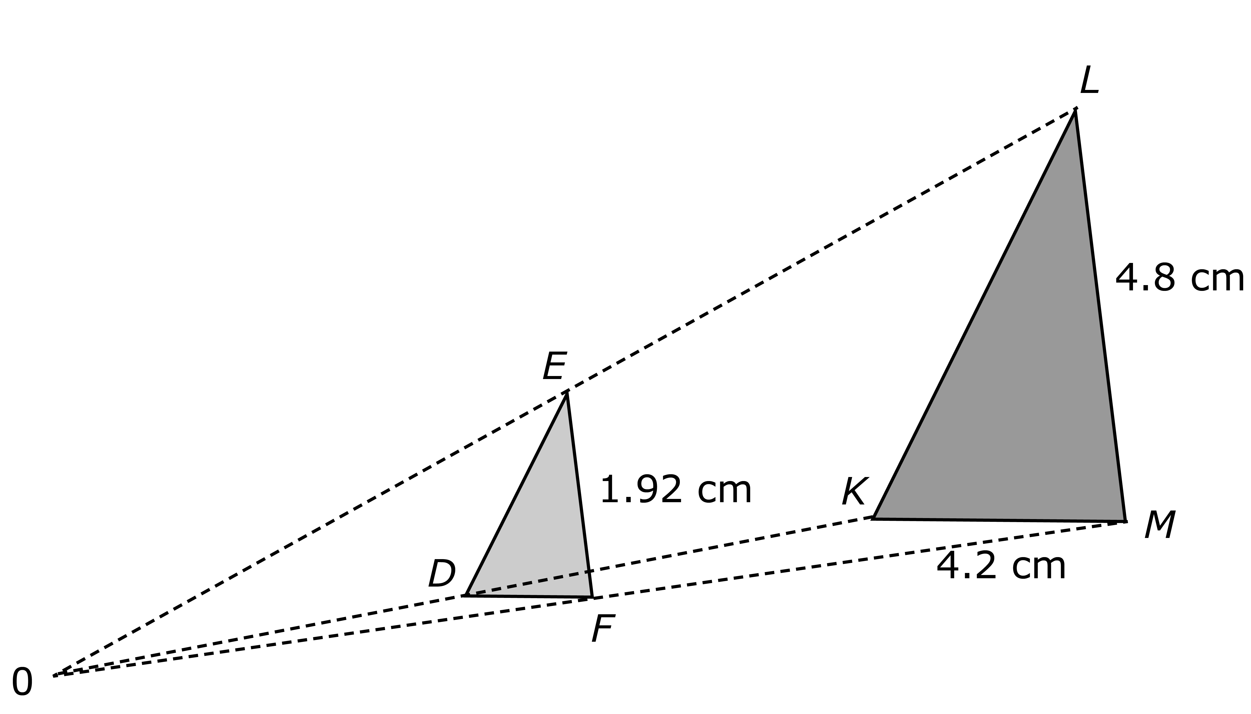

Find
(a) the value of ,

(b) the length of DF,

(c) the perimeter of DEF given that the perimeter of KLM is 14.6 cm.

Challenging

- Mr Aziz wants to paint a large rectangle on a wall. This large rectangle is an enlargement of another rectangle of dimensions 5 cm by 3 cm, with a scale factor of 11. However, he has 3 tins of paint only. Each tin can paint 470 cm² of wall. By some estimation, Mr Aziz knows that the 3 tins of paint are not enough for his painting work.
(a) By what whole number should Mr Aziz reduce the scale factor of enlargement?

(b) If it costs $1.24 to paint 10 cm² of wall, how much will Mr Aziz save after reducing the scale factor of enlargement?

