

**OCCUPATIONAL THERAPY**

ACTIVITY IDEAS

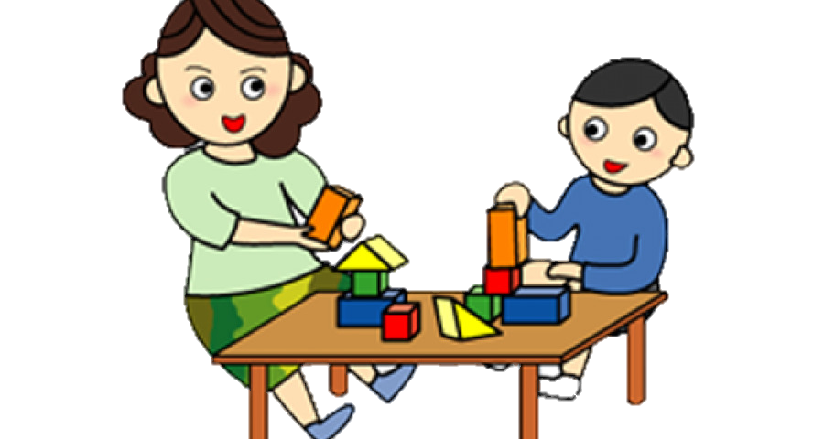

NOTE: please click the tab below to access link

Home-made puzzles

Activities in supporting student with sensory needs

Resources to support independence in Activities of Daily Living

Gross motor skills activities

Fine motor skills activities