**Further Practice 8.1**

Basic

1. Find the value of the unknown angle marked in each of the following diagrams. State the reasons.

(a)

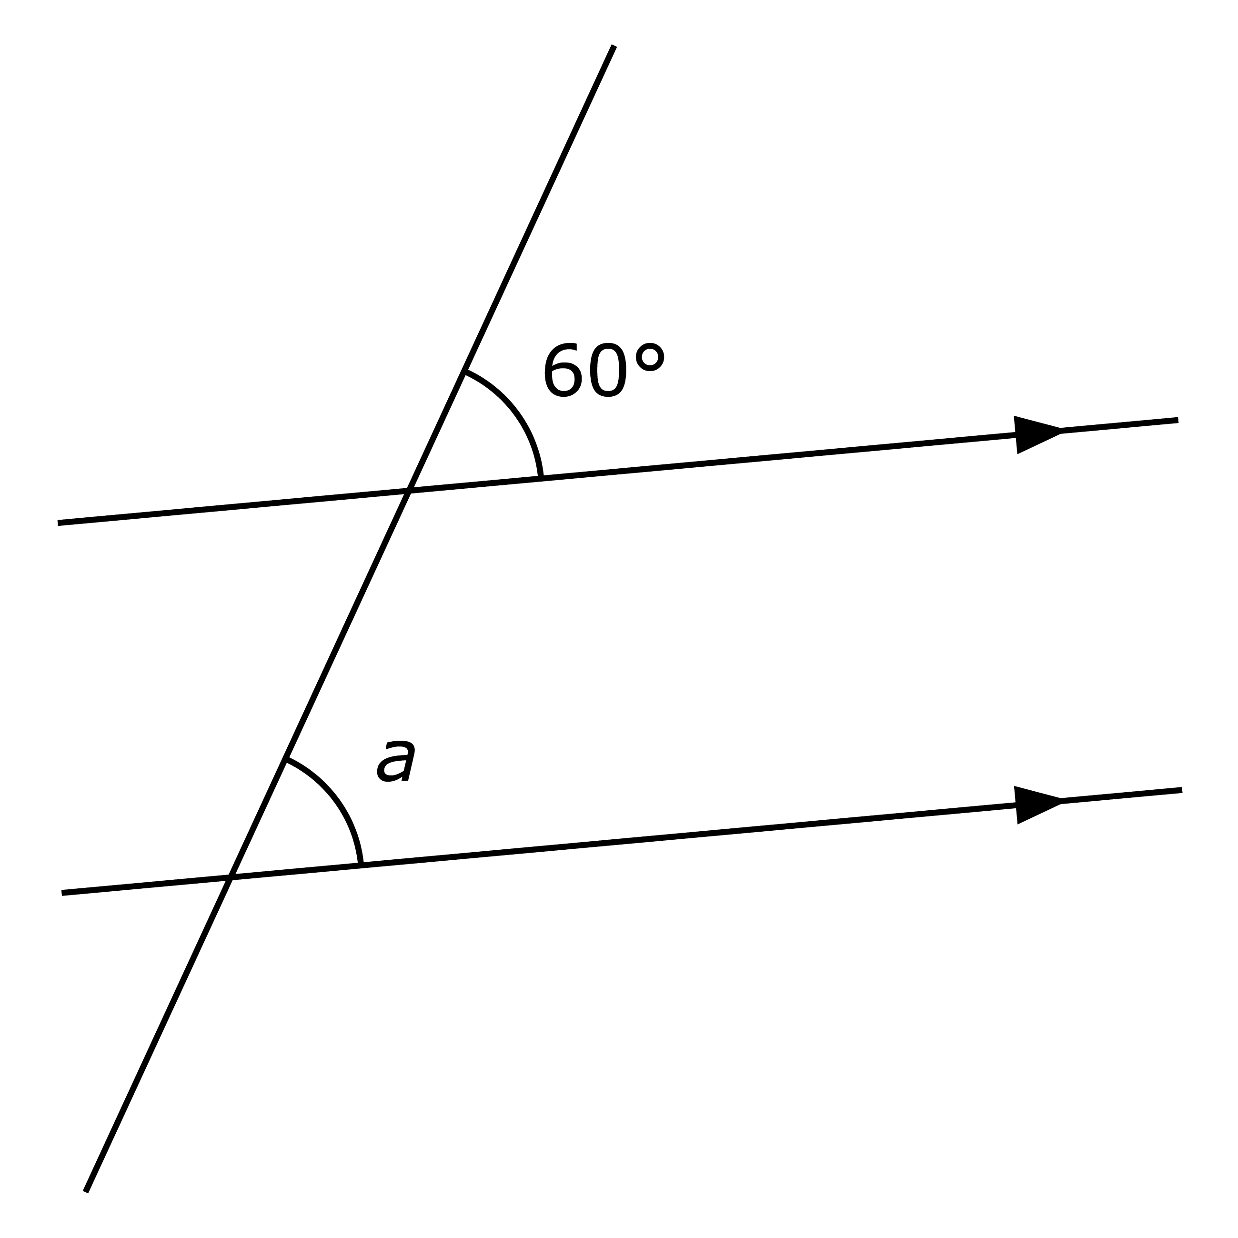

(b)

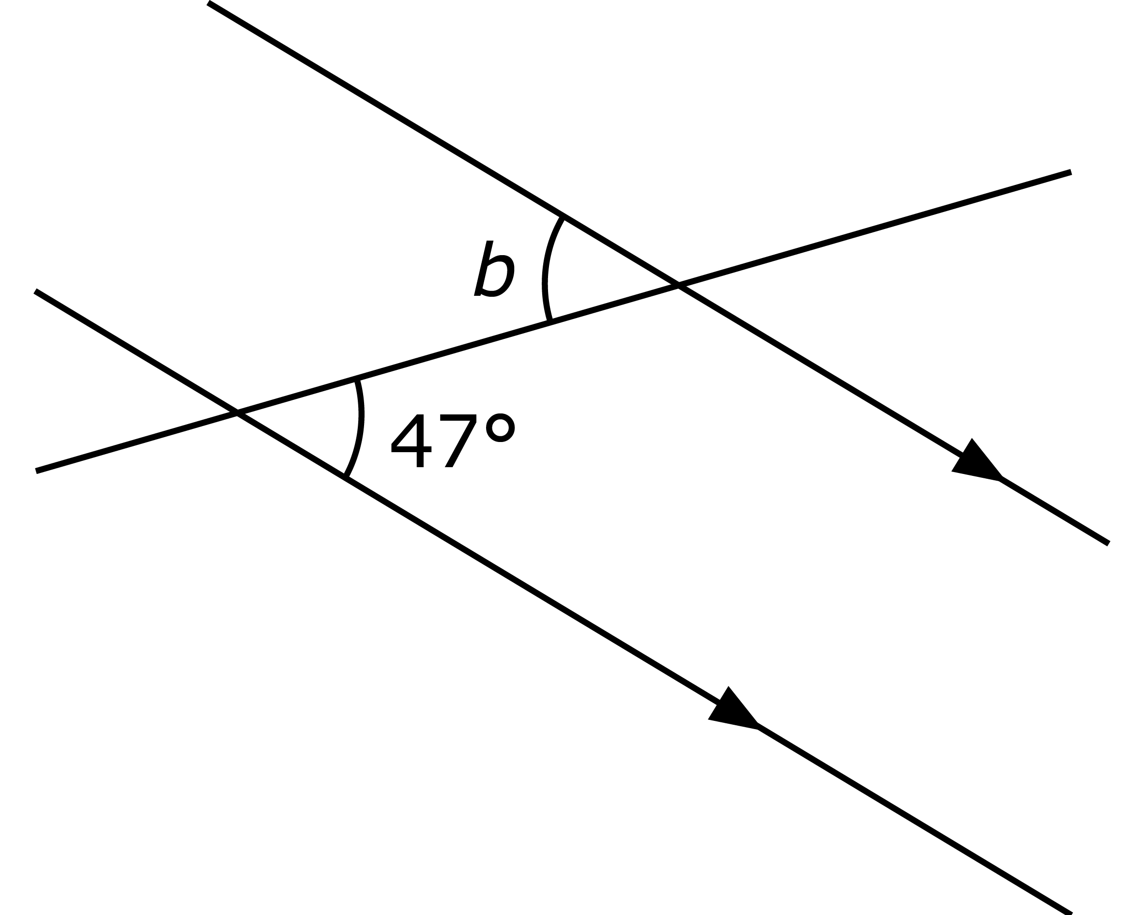

(c)

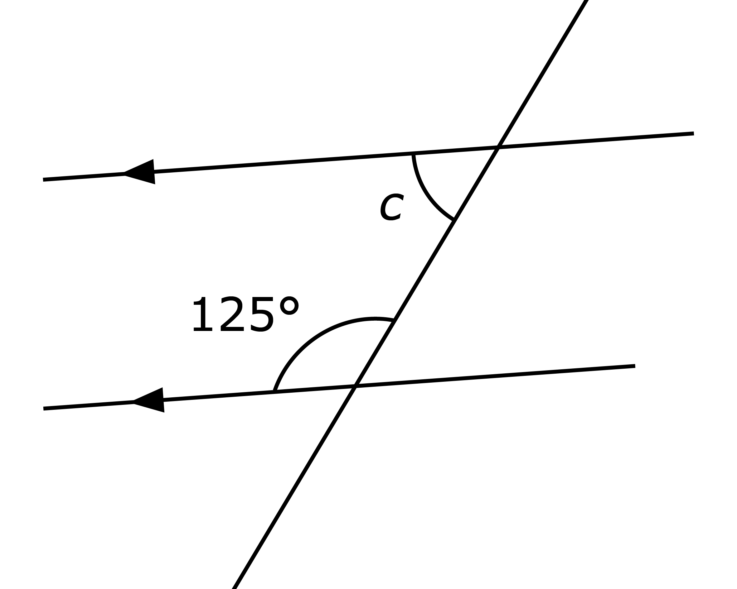

Intermediate

1. Find the value of the unknown angle marked in each of the following diagrams. State the reasons.

(a)

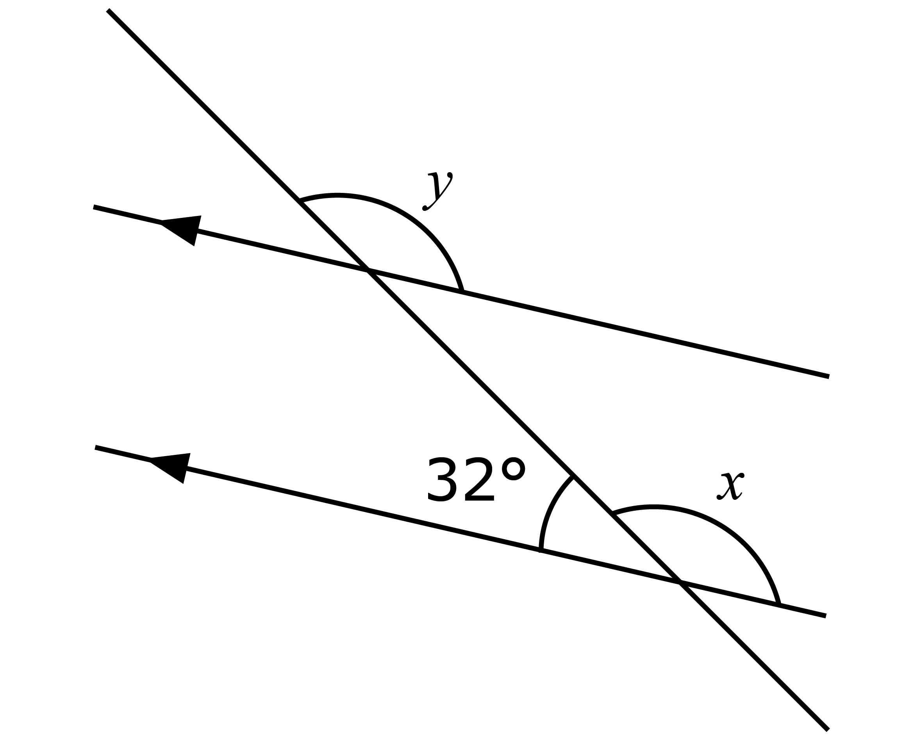

b)

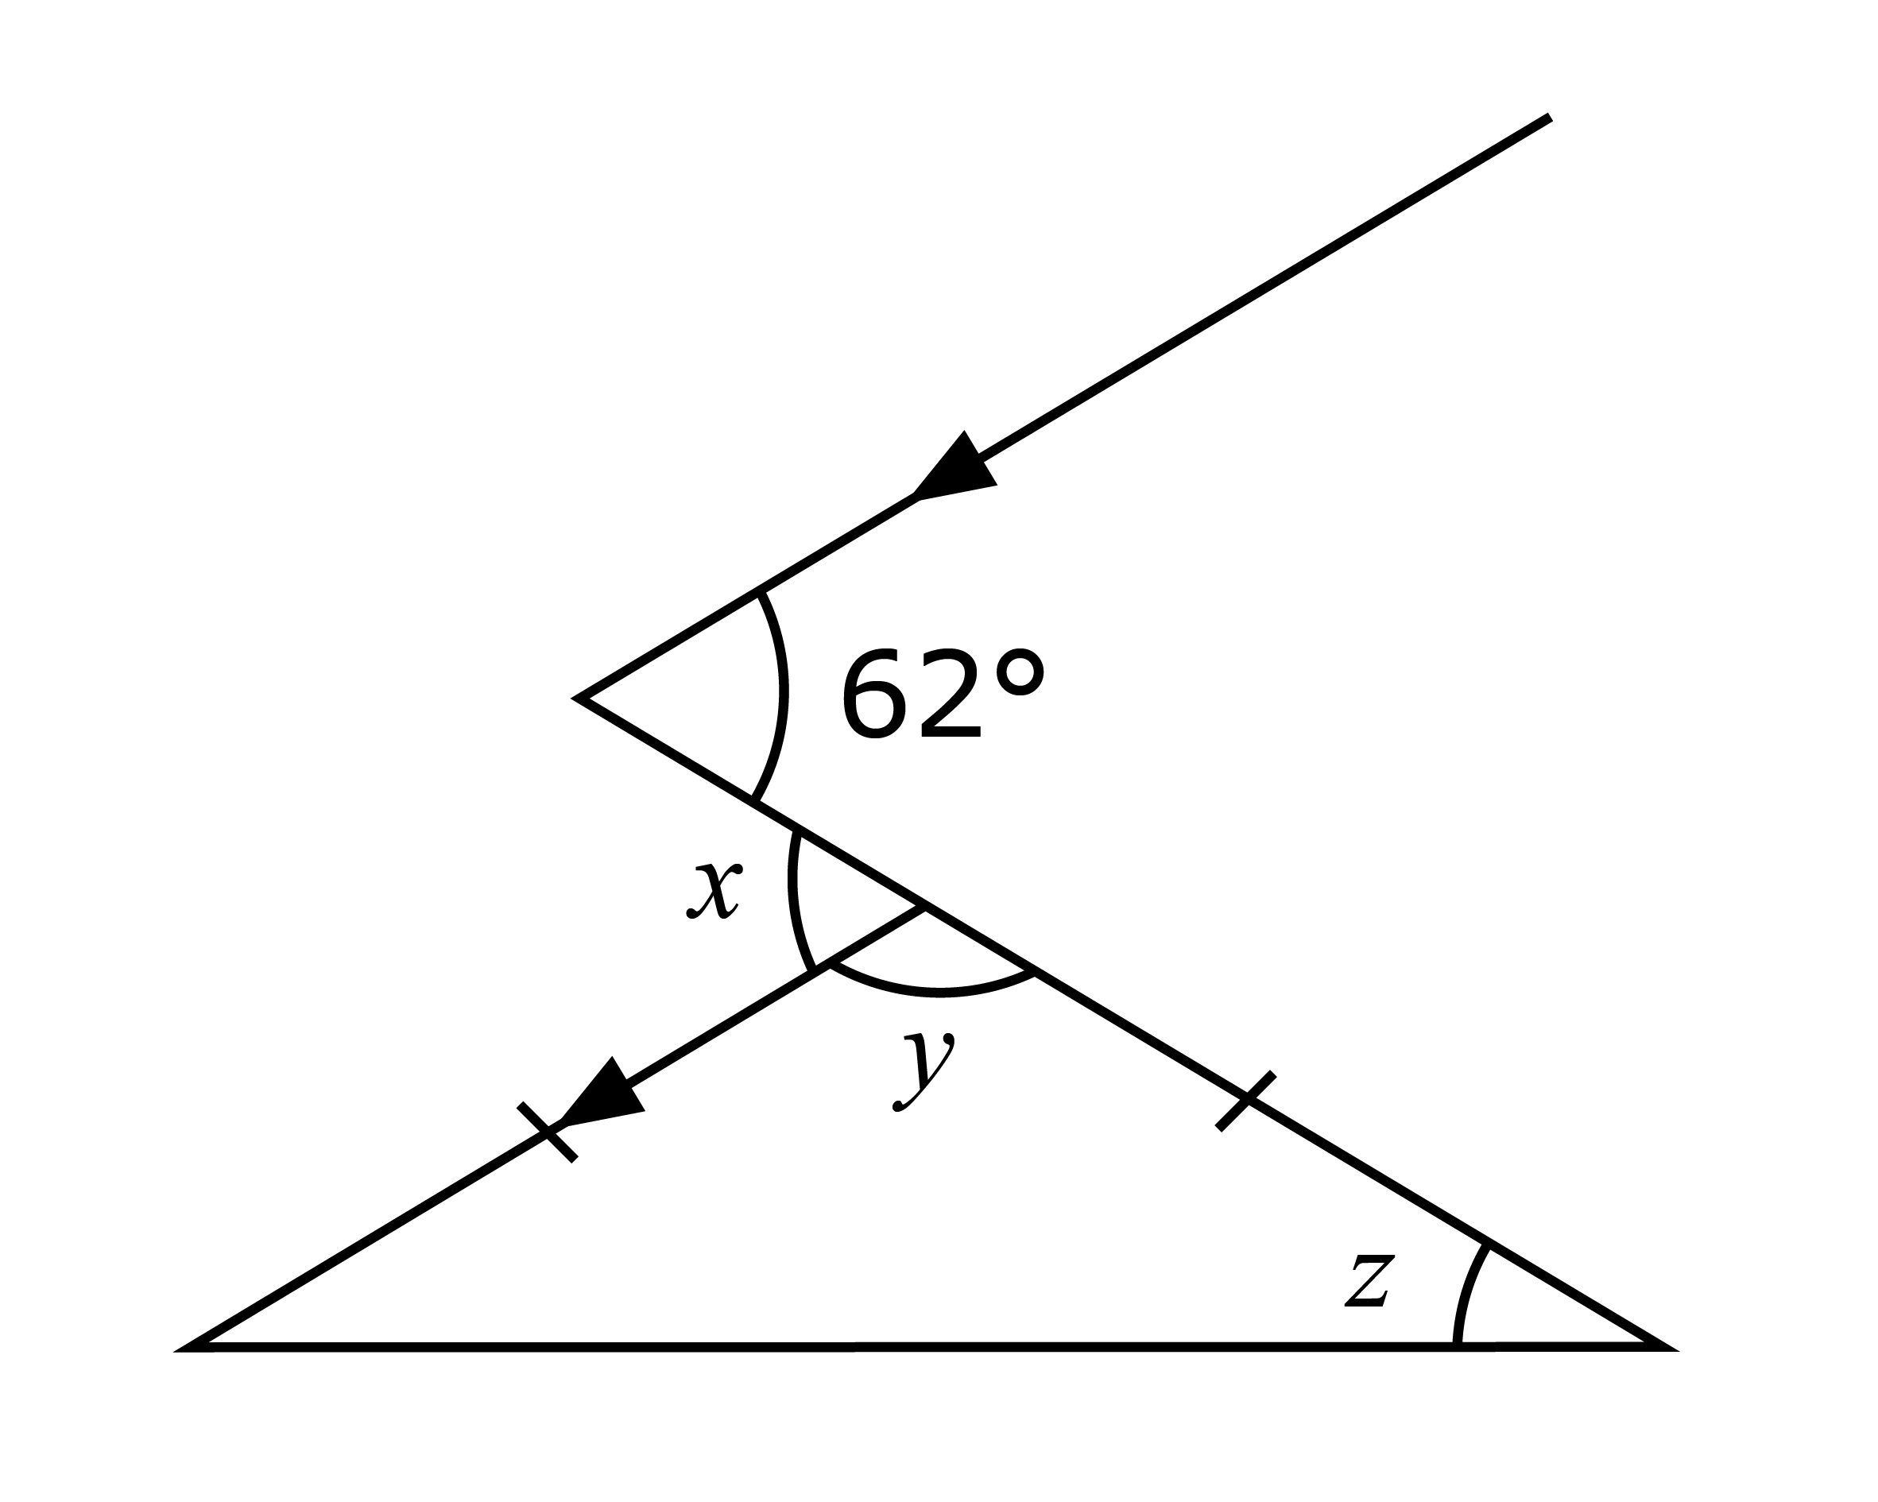

(a) Find the value of *g*.

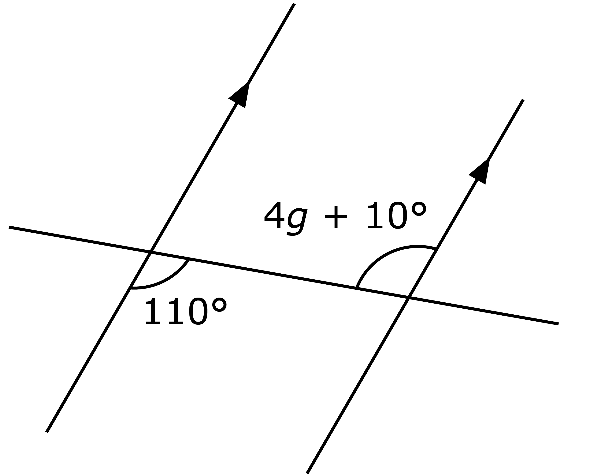

(b) Find the value of *h*.

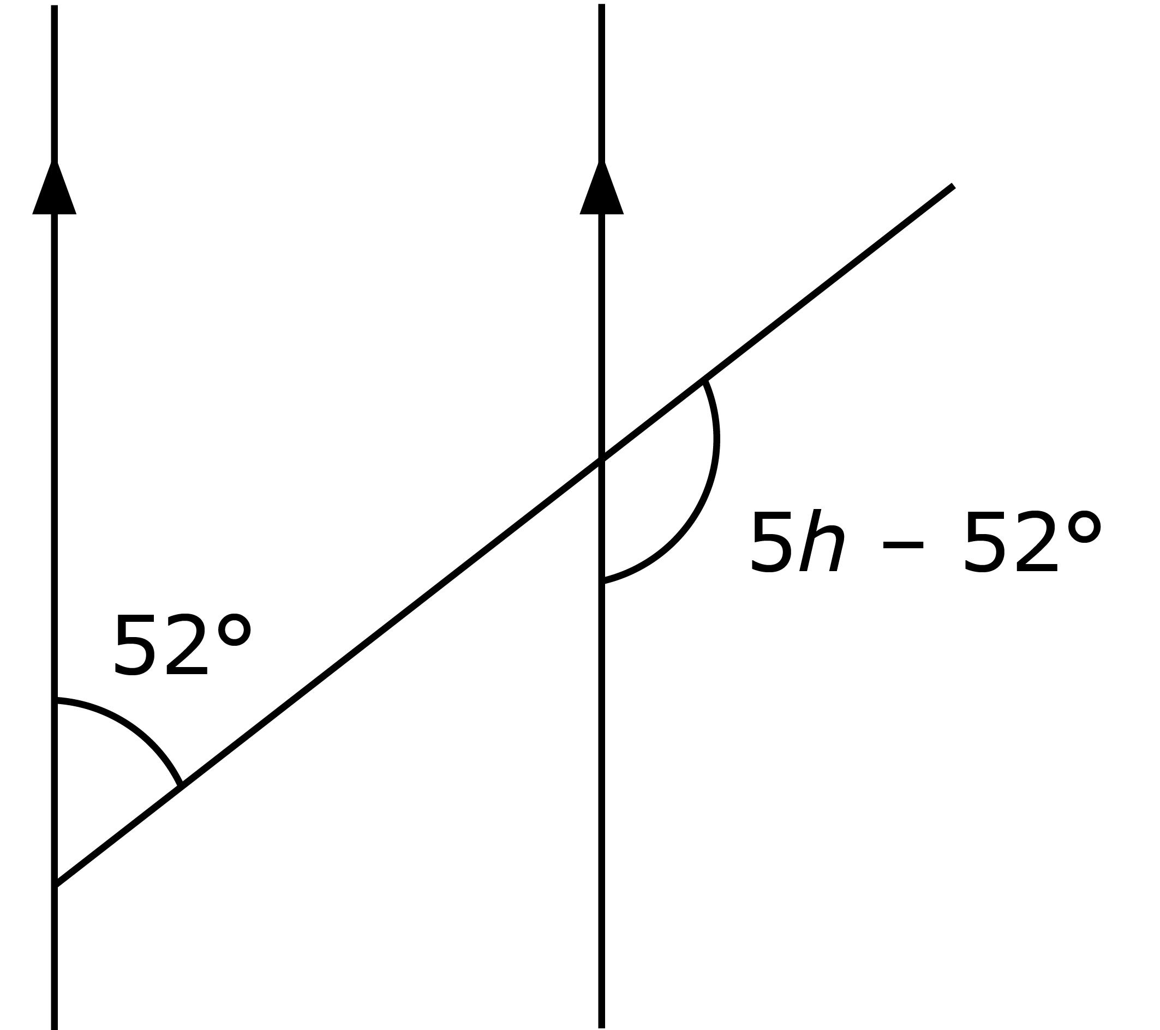

1. In the diagram, *AB*, *CD* and *EF* are parallel lines. *GHIJK* and *LMNOP* intersect the parallel lines. Given that *IJE* = 37° and *NOF* = 55°, find the value of

(a) *GHM*,

(b) *CNO*,

(c) *MNI* + *HIN*.

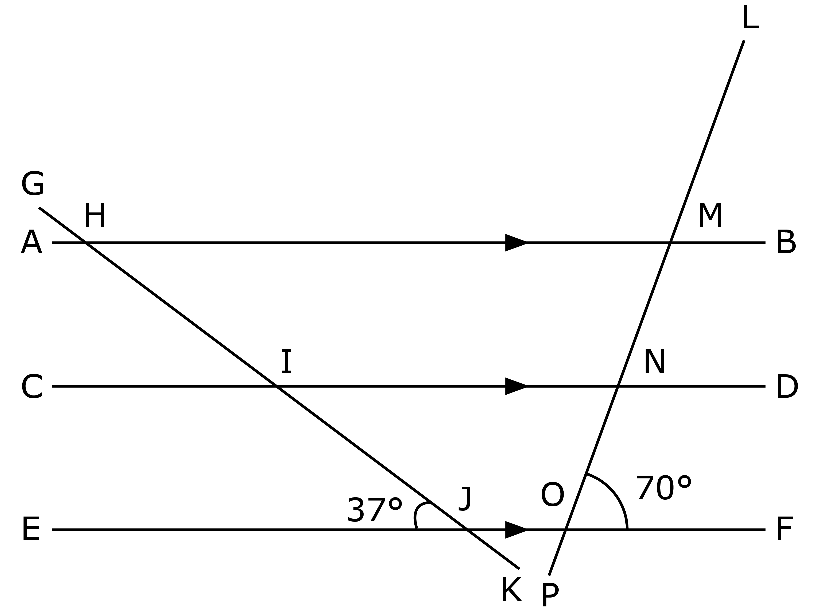

Challenging

1. Find the value of *x* in each of the following diagrams.

(a)

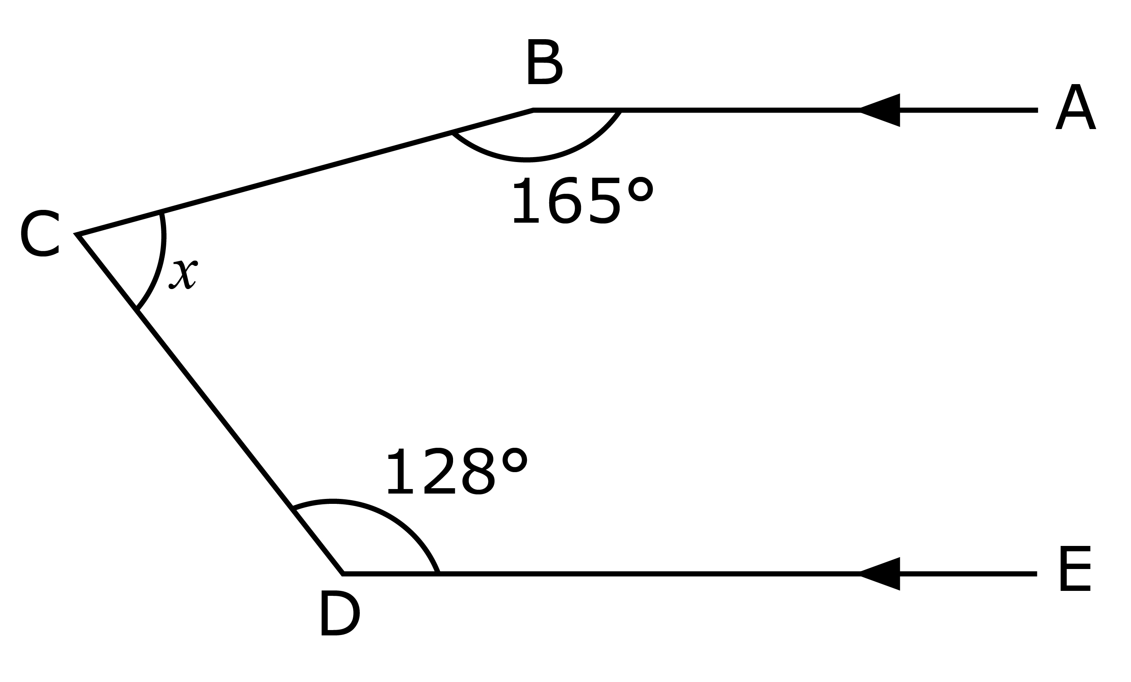

(b)

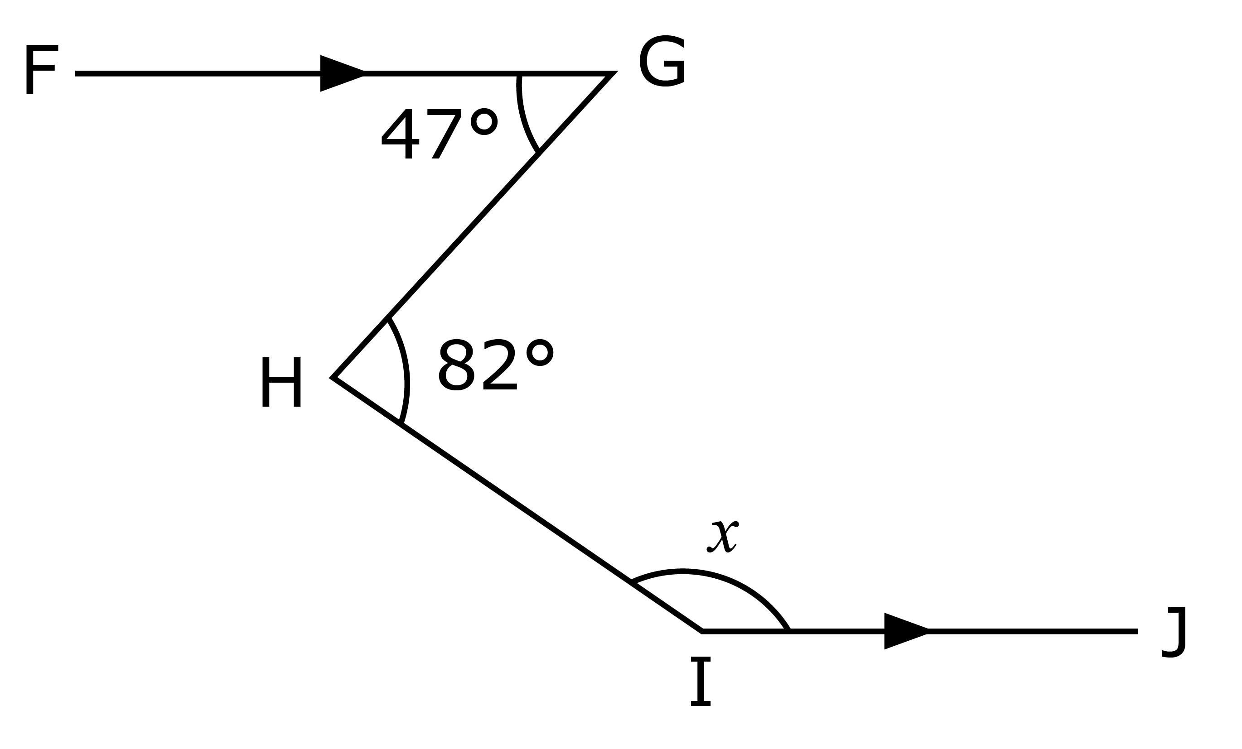

**Further Practice 8.2A**

Basic

1. Find the value of the unknown angle marked in each of the following quadrilaterals.

(a)

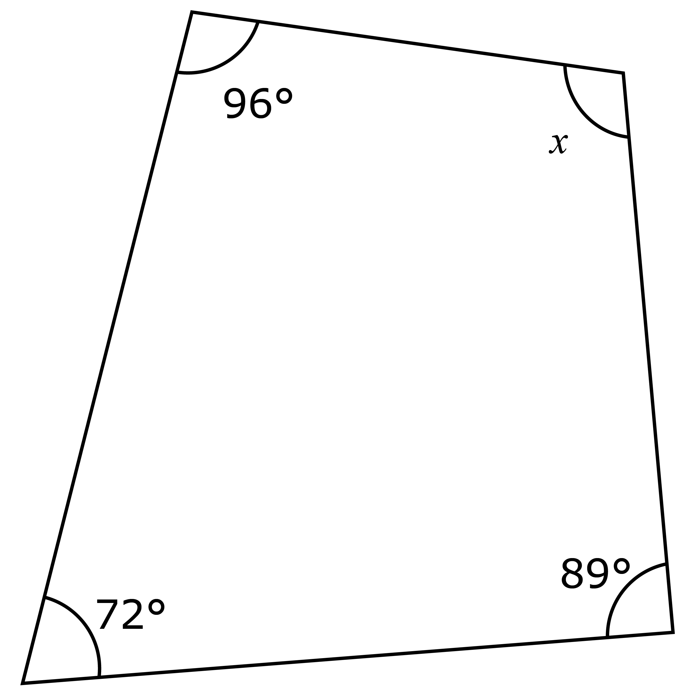

(b)

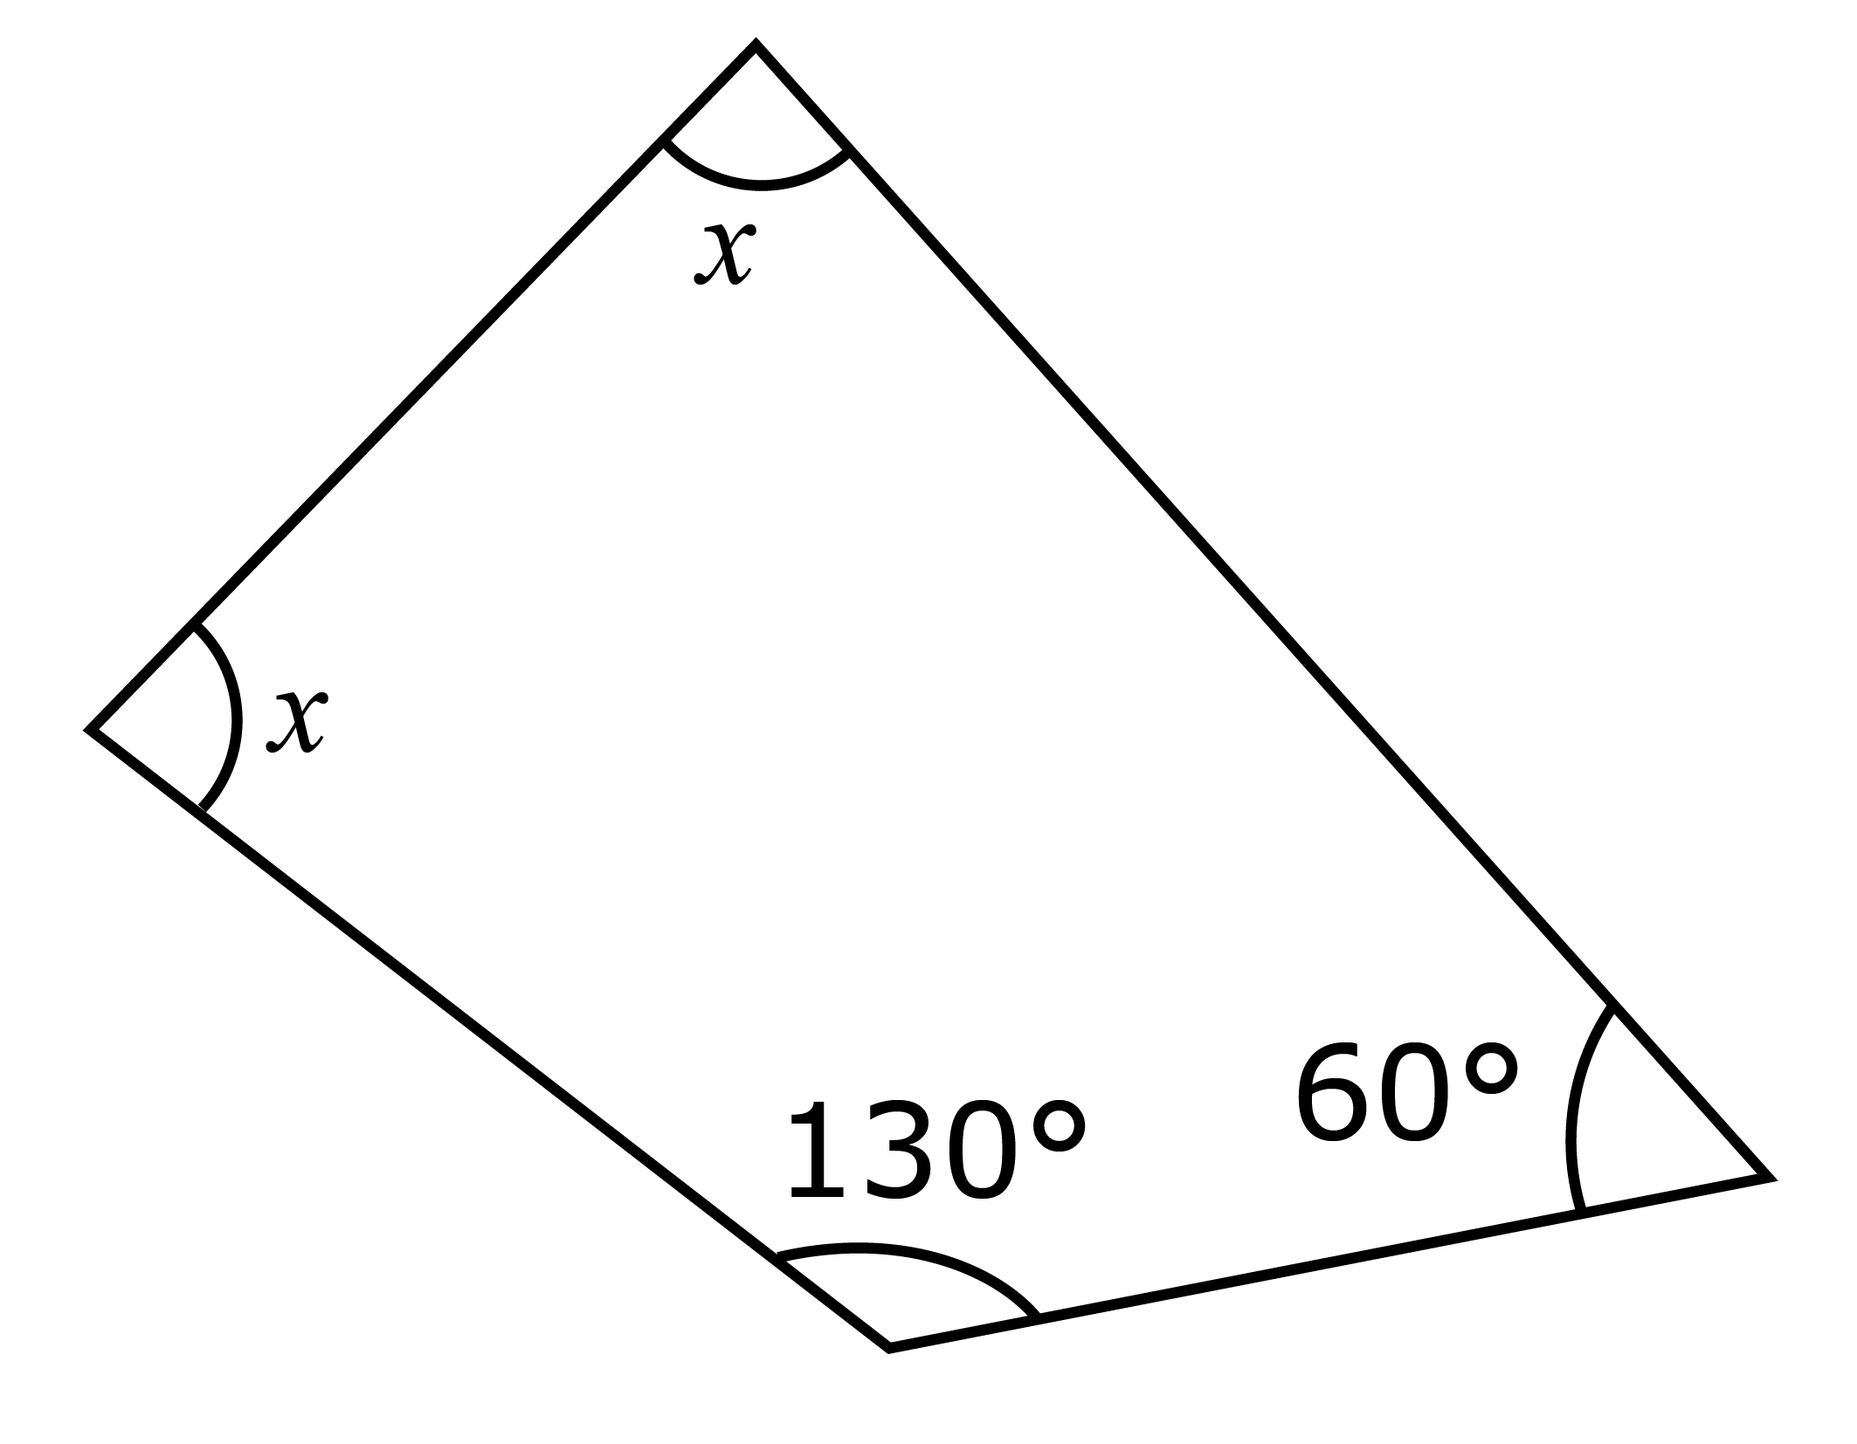

1. Find the values of *x*, *y*, *z* and *t* in each of the following quadrilaterals.

(a)

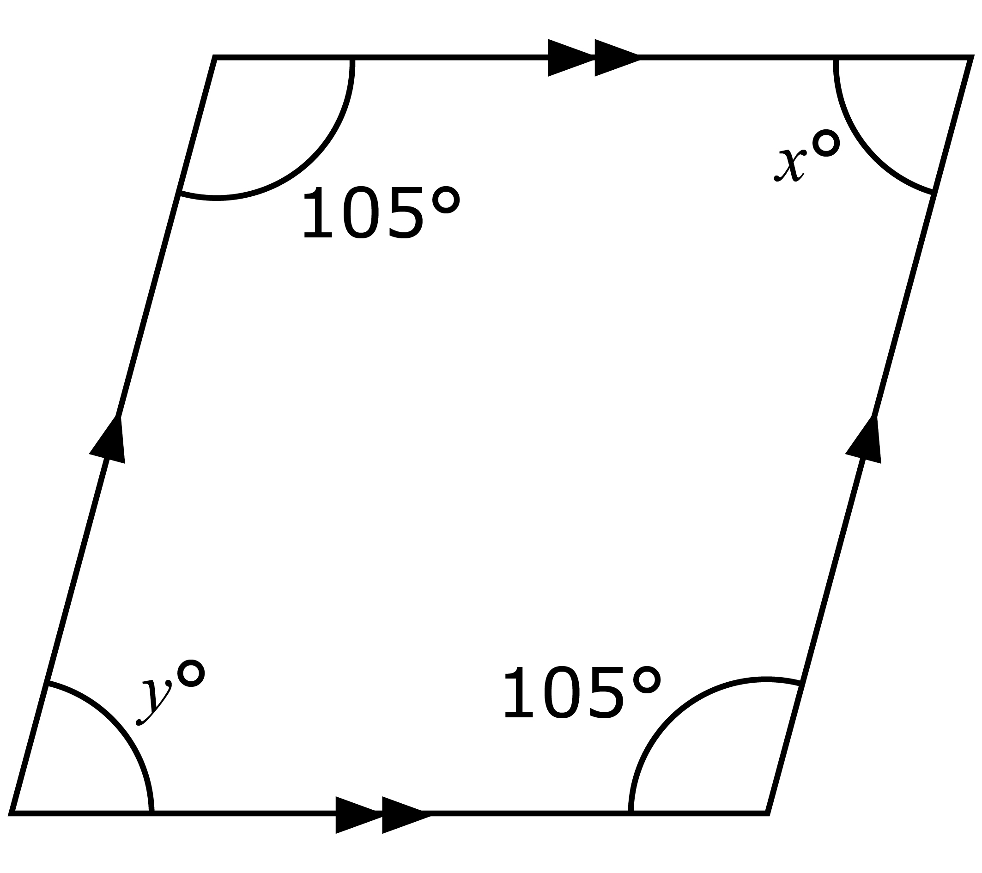

(b)

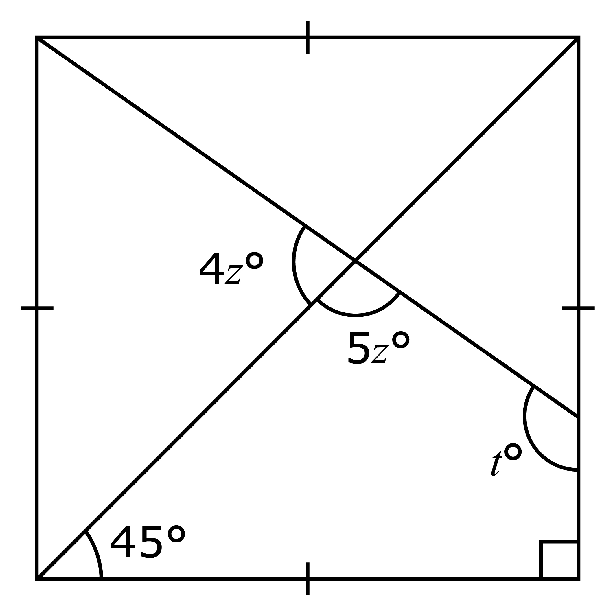

Intermediate

1. For each of the rectangles, find the unknown angles marked *x* and *y*.

(a)

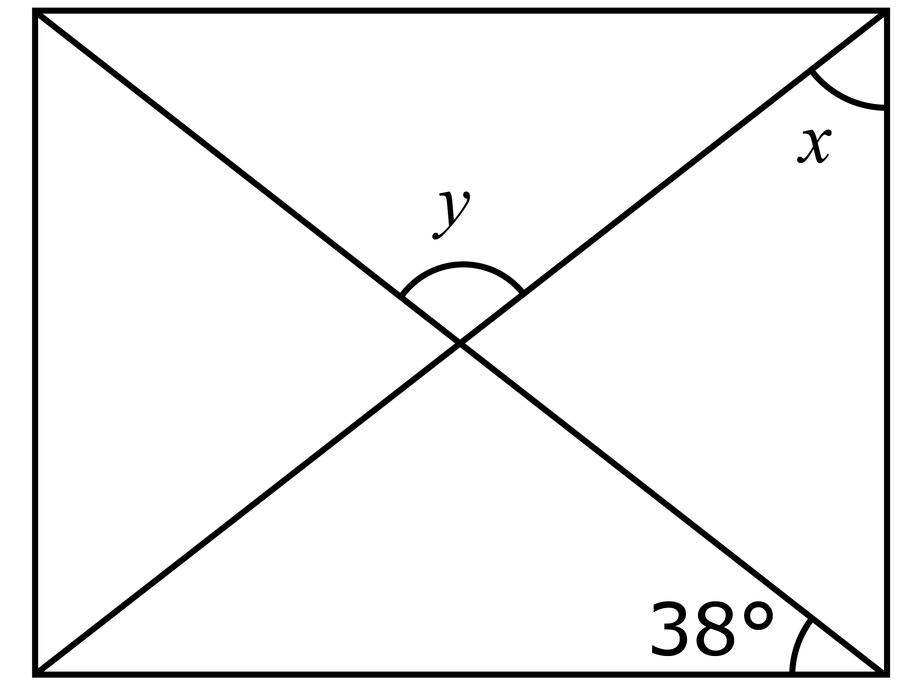

(b)

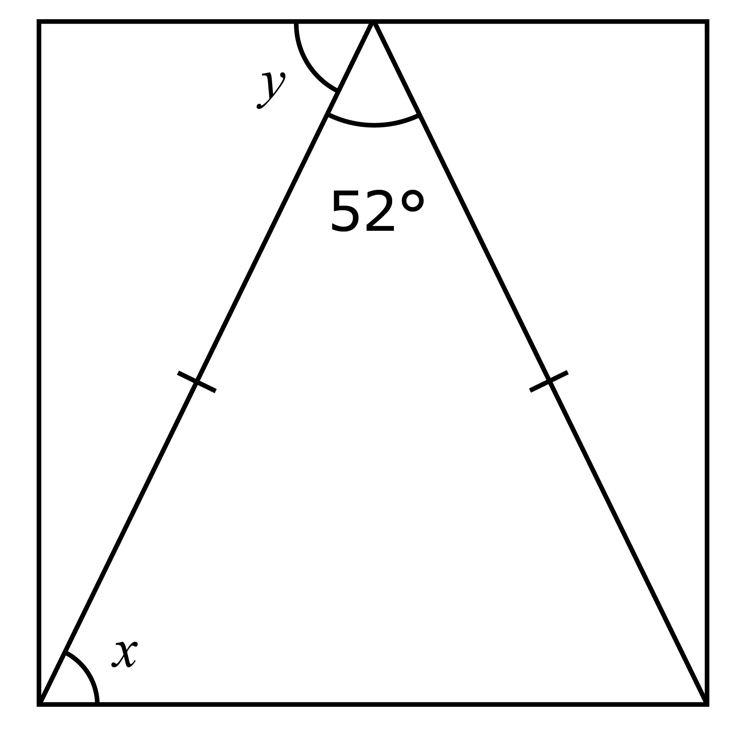

1. For each of the parallelograms, find the values of *x* and *y*.

(a)

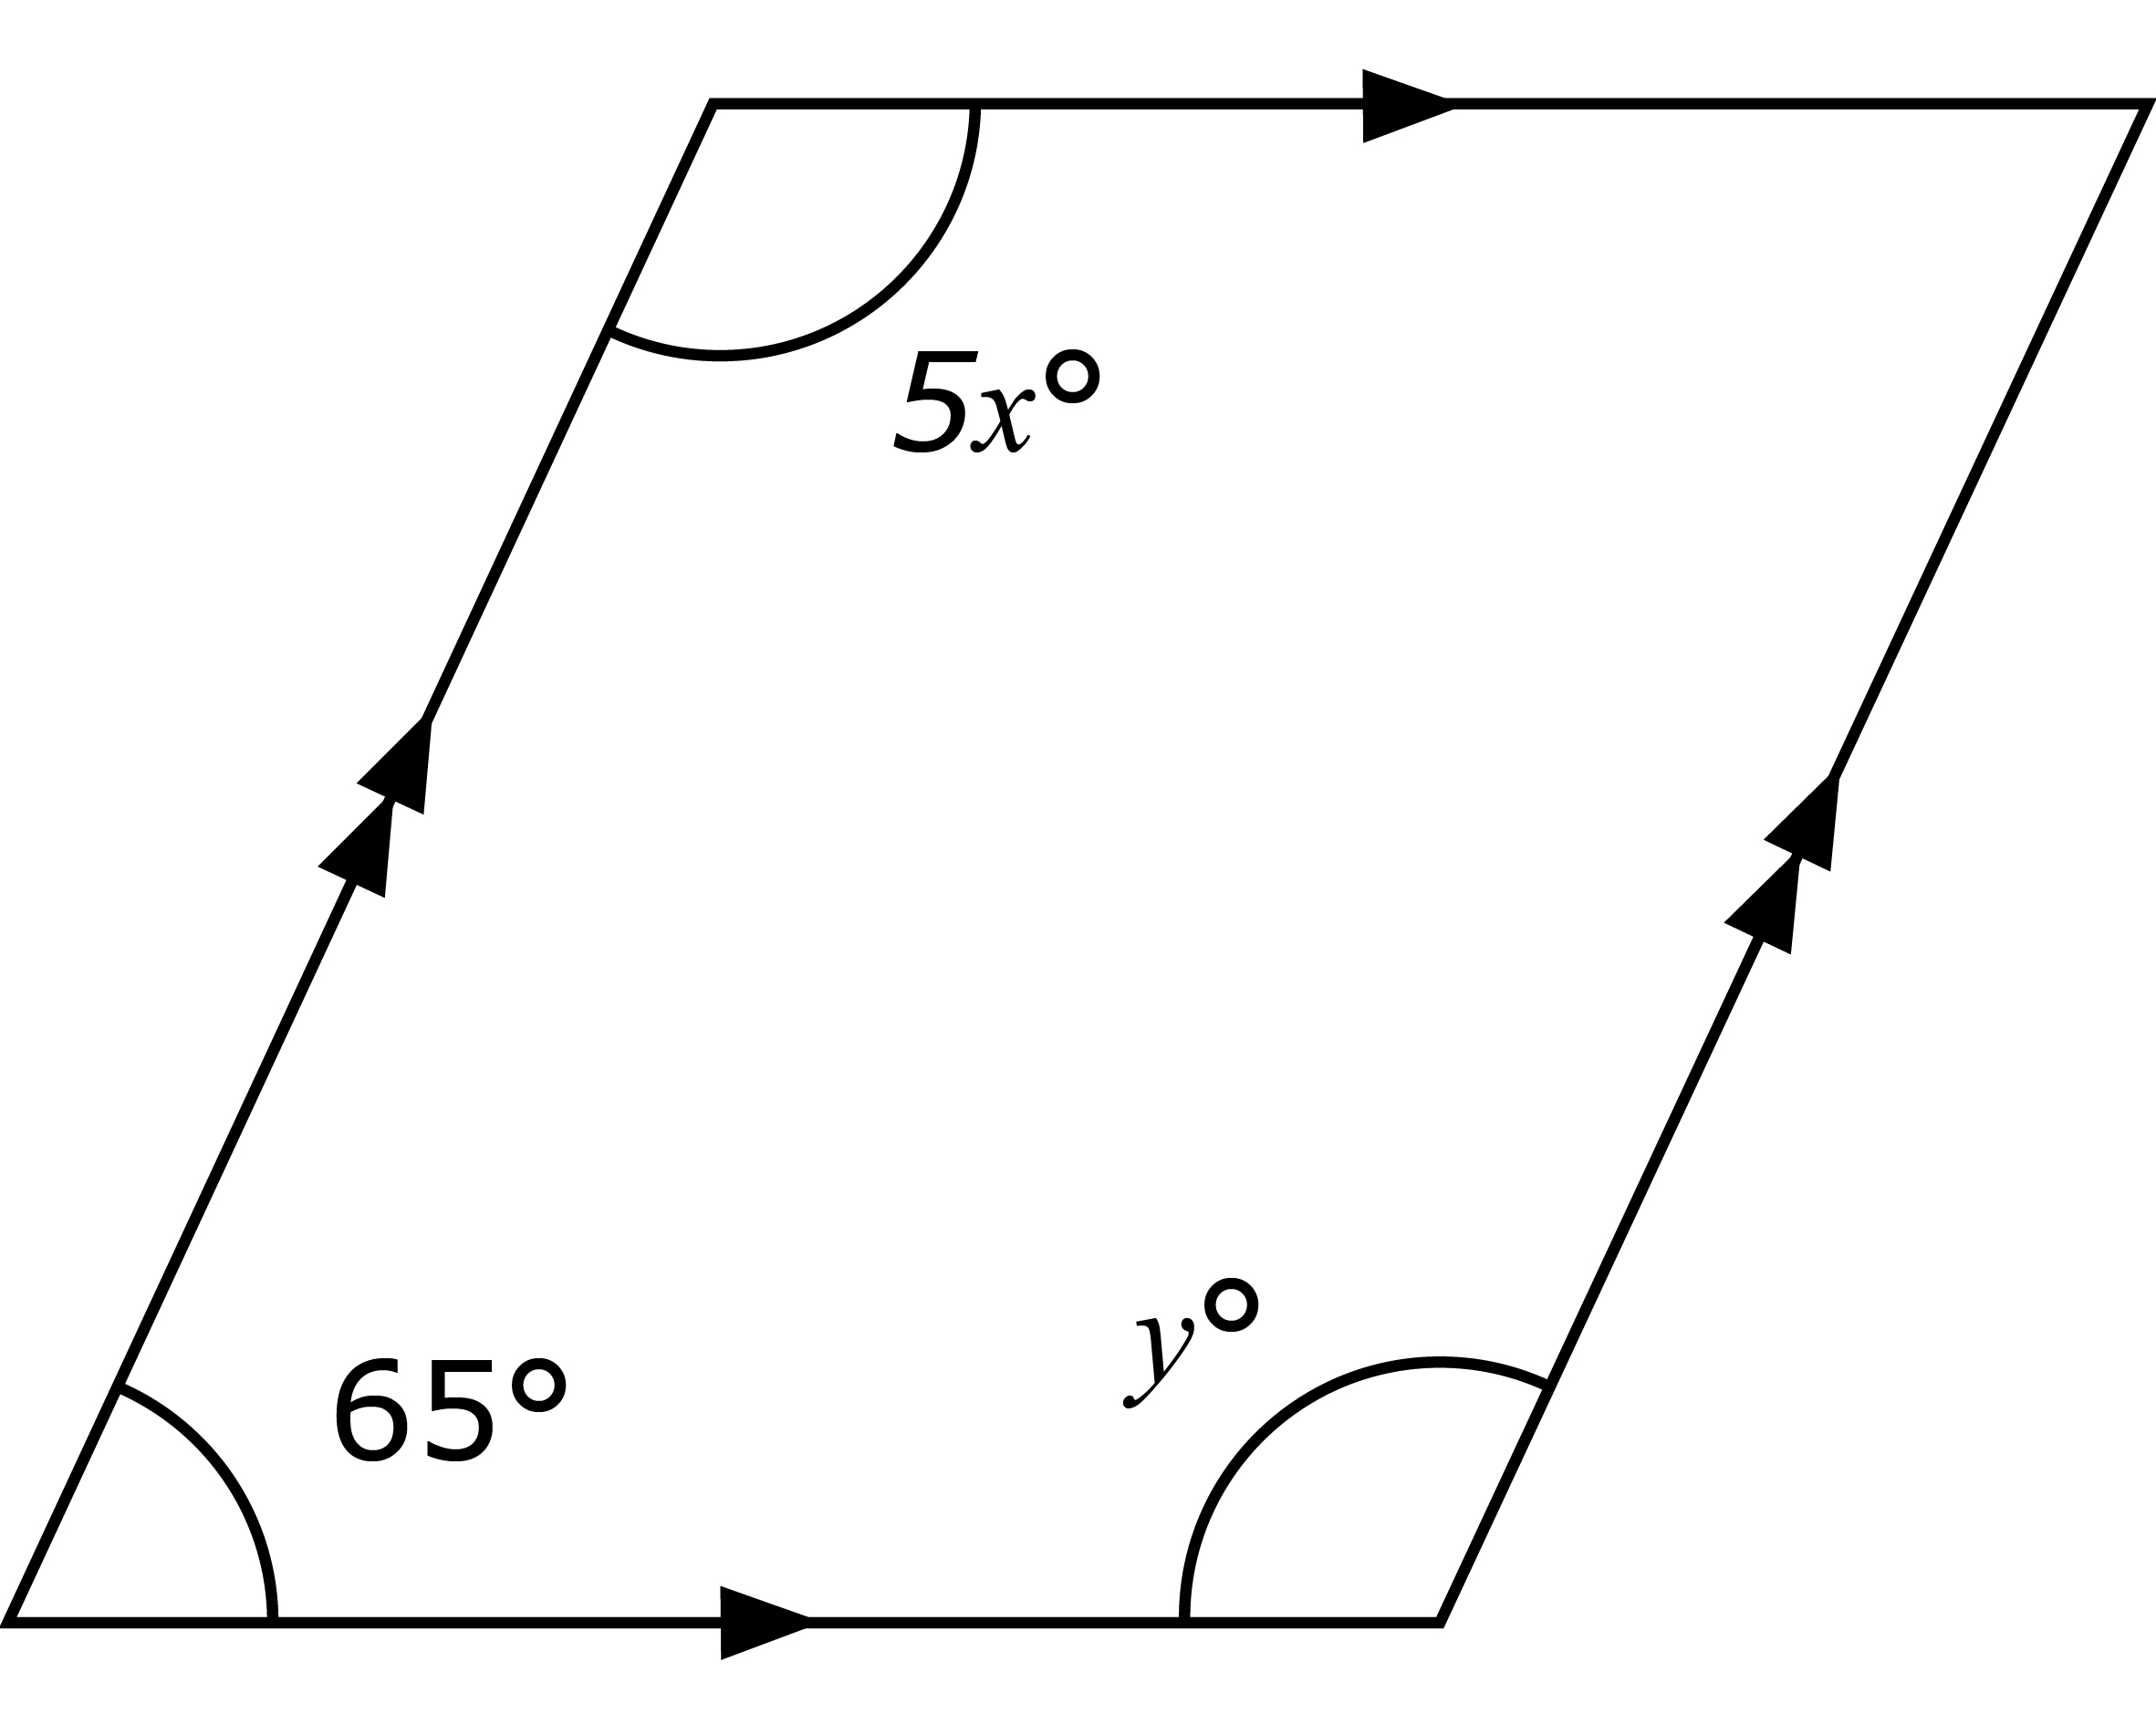

(b)

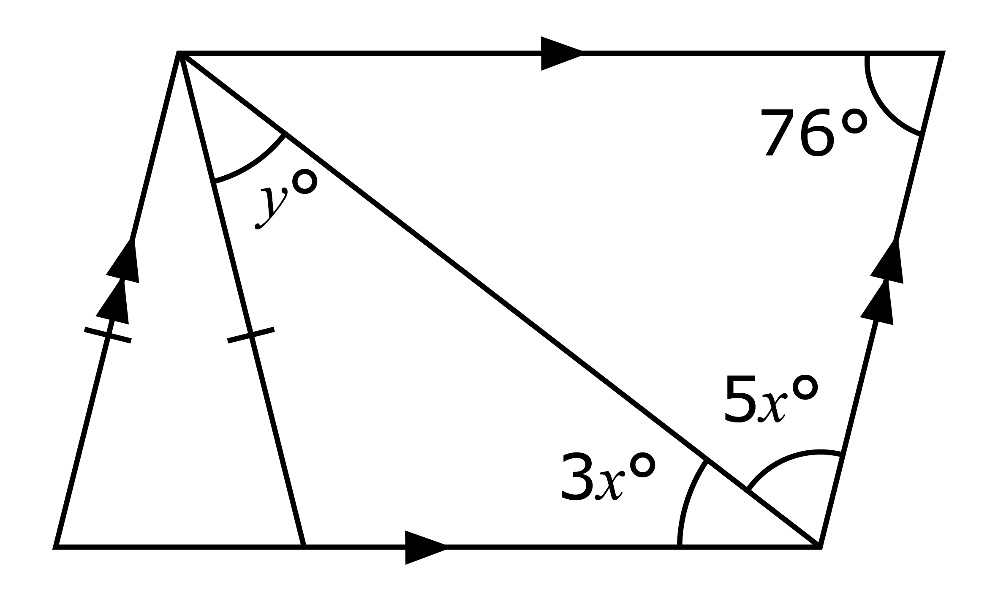

Challenging

1. *BCD* is an equilateral triangle. Find
2. *EDB* and
3. *ABC*.

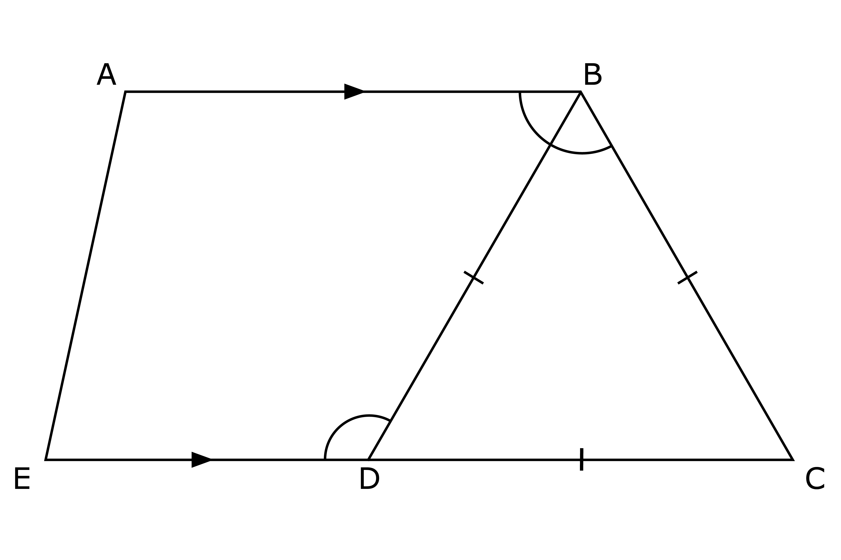

**Further Practice 8.2B**

Basic

1. Construct a rectangle with sides 8 cm and 5 cm.
2. Construct a parallelogram *PQRS* such that *PQ* = 4 cm, *QR* = 9 cm and

*PQR* = 60°.

Intermediate

1. *KL* and *LM* are 2 intersecting lines. *KL* = 3 cm, *LM* = 7 cm, and *KLM* = 120°.

A mirror is placed along *KM*.

1. Draw the resulting object and image.
2. State the special name of this quadrilateral.
3. *PQRS* is a quadrilateral in which *PS* is parallel to *QR*, and *PQ* is perpendicular to *PS* and *QR*. *PQ* = 4 cm, *PS* = 6 cm and *QR* = 9 cm. By constructing *PQRS*, find the length of *RS*.

Challenging

1. Mr Ali wants to fence a plot of land *PQRS* in which *PQ* = 60 m, *SPQ* = 75°, *SP* = 50 m, *PQR* = 120° and *QR* = 67 m. 8 m of fencing costs $42.70.

(a) Using a scale of 1 cm to represent 10 m, construct a diagram of the plot of land and find the length of *SR*.

(b) Calculate how much Mr Ali has to spend on fencing the plot of land, leaving your answer in 2 decimal places.